Cycle C April 25, 2021

The 4th Sunday of Easter

Title: The Voice of Jesus Resonates Forever in Our Hearts

Theme: The heart responds to the voice of Love with hope and faith, even in life’s darkest nights.

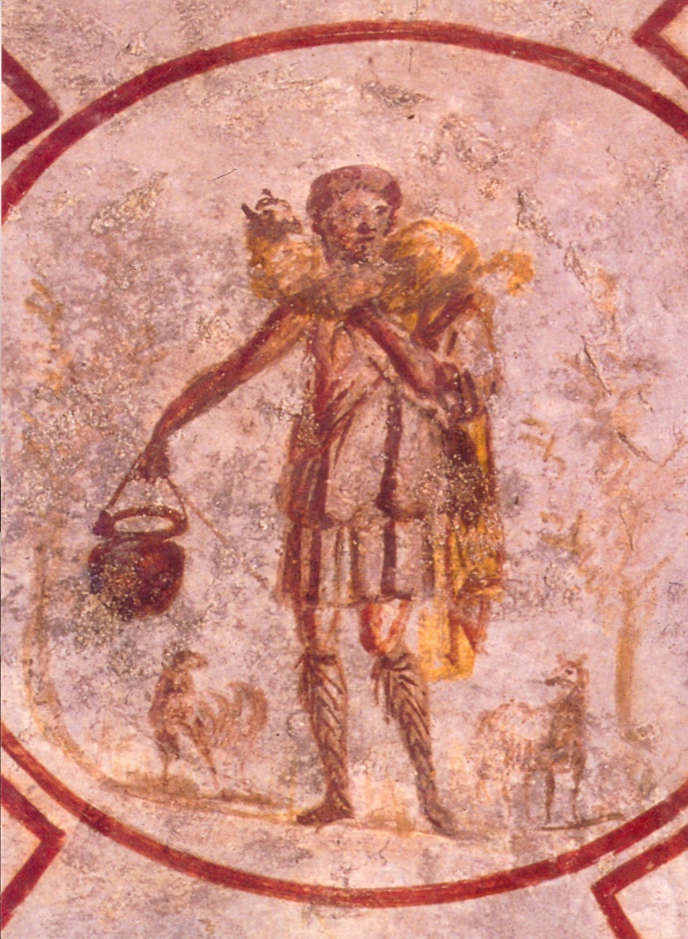 **Title: Catacomb of Callixtus – The Good Shepherd Date: Mid third century Building: Cimitero di Callisto City: Rome, Italy Medium: Painting on Rock of the Tombs**

**The Catacomb of Callixtus was built along the Appian Way, probably by Pope Callixtus in the early third century. As Christianity became prominent, catacomb remains were moved to churches and catacombs fell into disuse. “In the Catacombs of Callixtus, dating from the middle of the third century, the Good Shepherd appears again with delicate modeling of form, face and drapery.**

**Story: *Owl Moon*** by Jane Yolen illustrated by John Schoenherr

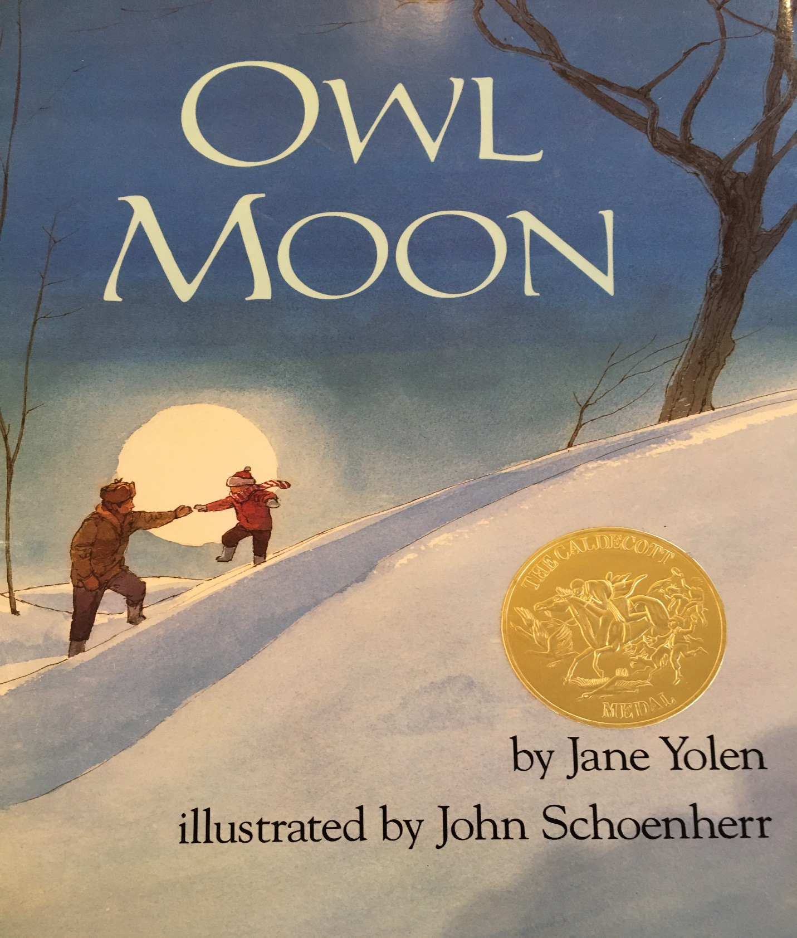

Sunday Gospel [JN 10:11-18](http://usccb.org/bible/readings/bible/john/10:11)

Jesus said:  
"I am the good shepherd.  
A good shepherd lays down his life for the sheep.  
A hired man, who is not a shepherd  
and whose sheep are not his own,  
sees a wolf coming and leaves the sheep and runs away,  
and the wolf catches and scatters them.  
This is because he works for pay and has no concern for the sheep.  
I am the good shepherd,  
and I know mine and mine know me,  
just as the Father knows me and I know the Father;  
and I will lay down my life for the sheep.  
I have other sheep that do not belong to this fold.  
These also I must lead, and they will hear my voice,  
and there will be one flock, one shepherd.  
This is why the Father loves me,  
because I lay down my life in order to take it up again.  
No one takes it from me, but I lay it down on my own.  
I have power to lay it down, and power to take it up again.  
This command I have received from my Father."

**Making the Connections for Parents and Catechists:**

Owl Moon is a beautiful story about the strength of voice recognition. In the dark forest a Dad and daughter tip toe silently through the woods. No words are shared, yet they speak to each other through the shared hope in their hearts. They are heading out on a late winter’s night to go owling. Pa cups his hands to his mouth and an owl hears a familiar hoot coming through the darkness of the forest. Through voice recognition old friends are reunited. Pa and the owl converse by the light of the silvery moon. It’s an enchanting night to share in, just the three of them. “All we need is hope that flies on silent wings under a shining Owl Moon,” says the little girl as they head home with their hearts full from this magical encounter.

Have you ever had a grandparent visiting from far away? When they walk in the house, call your name, your heart leaps with joy. Have you ever had a friend call you and when you answer the phone you feel your heart do a dance? Our voices are much like our fingerprints. They are unique, one of a kind and distinctive. When a person we love is down and out, we can hear it in their voice. Sometimes even more than we can see it in their faces. The tone of our voices, like our body language, can speak louder than words. Voice recognition is a very powerful thing. It speaks to the intimate connection we share with our loved ones of in our hearts and souls.

In today’s stories we hear about Jesus in the image of the Good Shepherd. In Jesus’ time shepherds were a part of daily life. The Shepherd’s job was to care for the sheep. Shepherds were given a big responsibility, to keep a herd of independent sheep moving together in one direction. As long as they stayed together, they would be safe. The shepherd knew he had to build an individual relationship with each sheep. From the time a sheep was very young they came to know the voice of the Shepherd. Lambs grew to trust equivocally the shepherd for care and protection. A bond, a union was established from the first day. A relationship of belief in each other. In First Century times there were few fences to keep sheep contained. The only way to keep the sheep safe was for the shepherd to build a relationships. Each sheep was connected to the shepherd, and the whole flock could move in unison by following the shepherd’s voice. This bond, established through care, gave the shepherd authority in the sheep’s life.

Jesus uses this analogy to invite each one of us to a relationship of a loving trust in Him. In this world we can’t see Jesus, but we can hear his voice in our hearts. As we follow his voice and develop strength of connection through prayer, Jesus like a Good Shepherd, will lead us to places of love and nourishment for our lives. He will help us to find the communities, work places, and friends that will provide us with the nourishment we need to blossom into all we can be. As we follow his voice he will always be there to guide us to during difficult circumstances.

The voice of Jesus the Good Shepherd gently leads us home. Home to ourselves, our hearts, and back to our loved ones when we go astray. Ultimately the voice of Jesus, The Good Shepherd, will lead us home to our Creator, guiding us safely through this world and into eternity, into the arms of our loving Father, forever.

**Bullet Points for Parents:**

* In the Easter gospels we learn of the new dynamics of life in the Risen Lord. They teach us how to recognize Jesus in new forms and how to experience this new life as the Body of Christ.
* Owl Moon is a beautiful story about the strength of voice recognition. In the dark forest a Dad and daughter tip toe silently through the woods. No words are shared, yet they speak to each other through the shared hope in their hearts.
* Pa cups his hands to his mouth and an owl hears a familiar hoot through the forest. Through voice recognition old friends are reunited. “All we need is hope that flies on silent wings under a shining Owl Moon,” says the little girl heading home from this magical encounter.
* Have you had a grandparent visiting from far away? They walk in the house, call your name, your heart leaps with joy. Our voices are much like our fingerprints, they are distinctive.
* When a person we love is down, we can hear it in their voice. Sometimes even more than we can see it in their faces. The tone of our voices, like our body language, can speak louder than words. Voice recognition speaks to the intimate connection we share with our loved ones.
* In today’s gospel we hear about Jesus the Good Shepherd. In Jesus’ time shepherds were a part of daily life. Shepherds were given a big responsibility, to keep a herd of independent sheep moving together in one direction. As long as they stayed together, they would be safe.
* The shepherd had to build an individual relationship with each sheep. As a young lamb they came to know the voice of the Shepherd and to trust the shepherd for care and protection. This bond, established through care, gave the shepherd authority in the sheep’s life.
* Jesus uses this analogy to invite each one of us to a relationship of a loving trust in Him. In this world we can’t see Jesus, but we can hear his voice in our hearts. As we follow his voice and develop strength of connection he will lead us to places of love and nourishment for our lives.
* Jesus will guide us to find the communities, work places, and friends that will provide us with the nourishment we need to blossom into all we can be. And his voice he will always be there to guide us to during difficult circumstances.
* The voice of Jesus the Good Shepherd gently leads us home. Home to ourselves, our hearts, and back to our loved ones when we go astray. Ultimately the voice of Jesus, The Good Shepherd, will guide us safely, into the arms of our loving Father, forever.

**Making Connections for Children:**

1. Have you ever gone on a quiet walk in the woods?
2. What have you heard?
3. Does every little sound come alive?
4. Do you ever wake up in the morning and hear all the birds outside?
5. Do you listen or do you ignore them?
6. Do you think the little girl felt pretty special to get to take this great adventure with her Pa?
7. Was is a rite of passage?
8. Did her Pa know the way?
9. What was her job?
10. Was trust and hope important?
11. How did the owl respond once it recognized the call?
12. Can you hear God’s language in your heart?
13. How does it feel?
14. How do you hope to respond?
15. What does knowing that Jesus the Good Shepherd will always recognize your voice when you call do for you?
16. How might you practice listening for the Good Shepherd’s voice in your life?

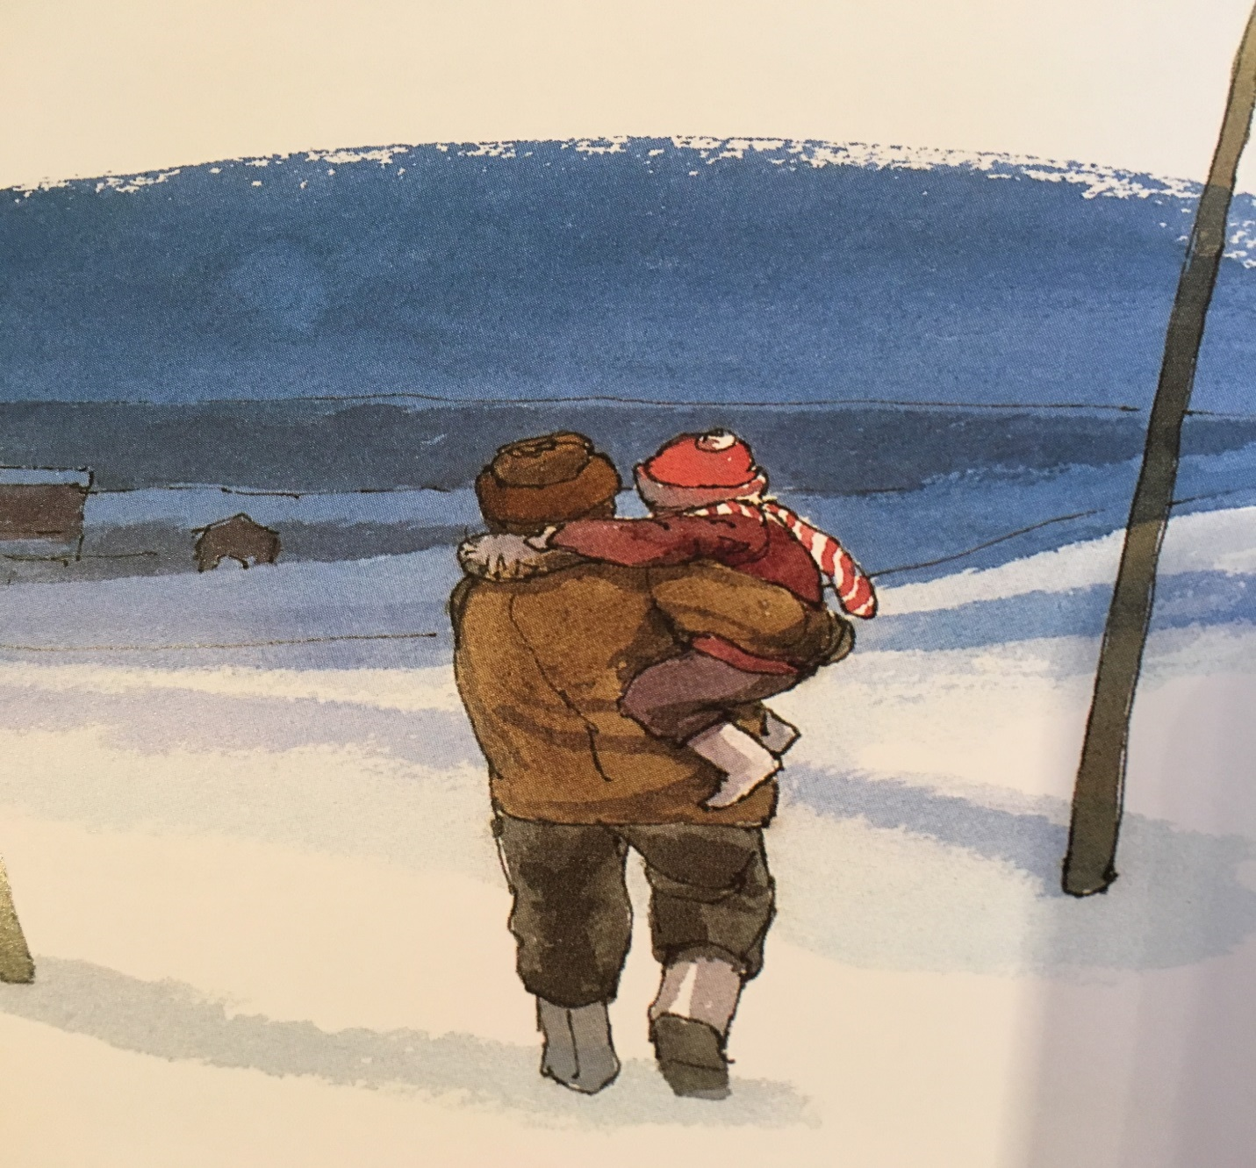 **Question of the Week**: Talk as a family about what it means to know that you can always hear the voice of Jesus the Good Shepherd to guide your life. What does it mean to know that the voice of Jesus will be with you to lead you from this world to the next?

**Gospel Qualities: well-nourished inner listening**

**Additional Family Activity**: Practice as a family communicating with an animal. Notice how animals communicate. What do they say without using words? What do they learn from us without using words? What can we learn about how we communicate with God without words from animals? Practice talking and listening without words with an animal and then share as a family about each experienced.

**Biblical Background Cycle B The 4th Sunday of Easter Gospel** [**JN 10:11-18**](http://usccb.org/bible/readings/bible/john/10:11)

**Geographical Location:** Most of Israel/Palestine is a rocky and hilly desert climate. Only in Galilee are their lush fields that are good for agriculture. Thus, part of being the land of milk and honey is to be a land that is not optimal for agriculture but is good for sheep. Thus, the sheep and goats produce milk and a land flowing with milk is the result. People lived very close to the land and sheep and shepherds were abundant. Thus, it’s a very familiar sight for Jesus to describe as a parallel to who he is in relationship to his followers.

**Terms: Hired man**- The hired man is an employee thus the bond is money not love. Therefore he would not be invested in the fate of the flock as one who just puts his time in.

**Good Shepherd** - goes out after those that are lost, will risk their life out of love and a bond to the sheep, a loving relationship that requires the shepherd to go to great lengths to protect the sheep even to the point of offering one’s life. Sheep needed to be protected from wild animals, mountain crevices, and become cast down, i.e. Fallen over and unable to right oneself.

**Power to lay it down and pick it up again –** Jesus is foreshadowing here his own death, indicating a set of difficult circumstances, but it is part of the fulfillment he is to realize. He is to fulfill the prophecies and chooses the Passover in connection to the sacrificial lamb as his appointed time.

**Insights into Culture –** In the time of Jesus sheep herding was a prevalent profession, thus everyone would understand what is required of the Shepherd in caring for his sheep. It would have been common knowledge. Just as football is a big part of American culture. Thus, when people make football analogies, people can understand the meanings they are referring to. The shepherd has a personal relationship with the sheep, a deep bond of love and fidelity. A hired hand does not share in that bond of care and relationship. For the hired hand, it does not drive him, he is driven by money not relationship. Here Jesus is saying to be driven by money versus love will have disastrous results.

**Insight into meaning-** “I know mine and mine know me” – Sheep were familiar with their shepherd’s voice, it is how sheep sorted themselves. They knew in a mixed herd who they belonged to, who they were bonded to, who would care for them to the point of laying down their life for them. Shepherds that were not theirs, did not have a bond to them therefor would remain detached in the case of danger, much like the hired hand. They did not have anything to lose if they lost the sheep. The shepherd loved his sheep and was in a state of relationship, for that loving union a shepherd would take great risks for the safety and wellbeing of the sheep. That is what constitutes a Good Shepherd, one who is bonded in a loving relationship and who will risk their very life to protect and care for the sheep. That is the defining difference from a hired hand.