Cycle A Jan. 26, 2020

The 3rd Sunday in Ordinary Time

Title: Called to LIFE Extraordinaire!

Theme: Called by Jesus out of the doldrums of life into the greatest journey offered in heaven and on earth.

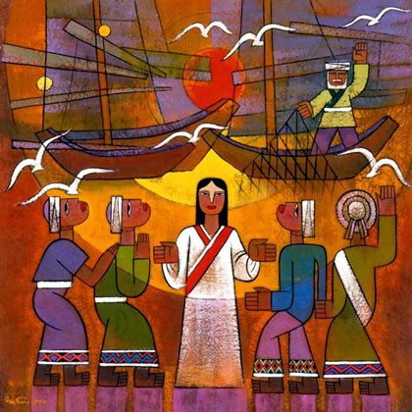

Title: Calling Disciples Artist: He,Qi Meduim: Painting Date: 2001 Country: China

Notes: Dr. He Qui is a professor at the Nanjing Union Theological Seminary. He is a member of the China Art Association and a council member of the Asian Christian Art Association.

Story: Jumanji

written and illustrated by Chris Van Allsburg

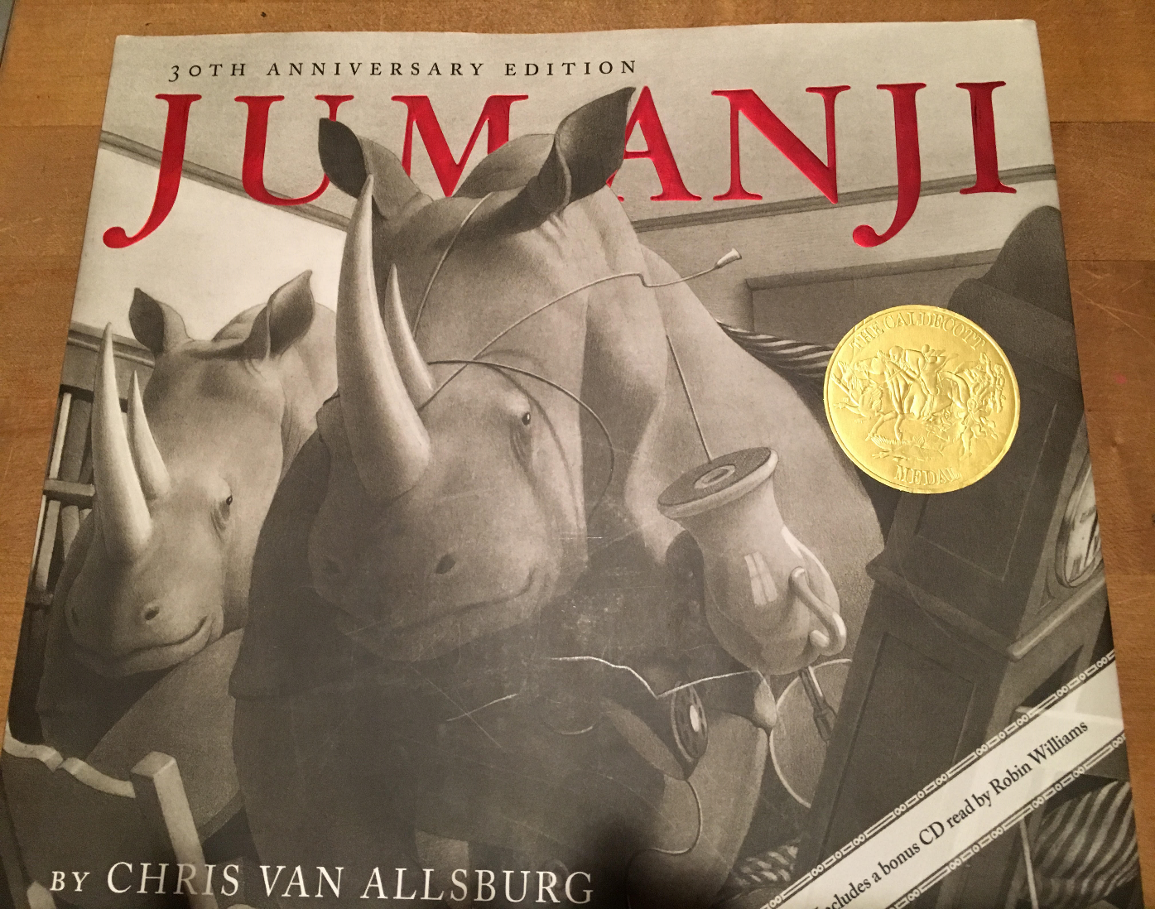

Sunday Gospel

MT 4:12-23

When Jesus heard that John had been arrested,  
he withdrew to Galilee.  
He left Nazareth and went to live in Capernaum by the sea,  
in the region of Zebulun and Naphtali,   
that what had been said through Isaiah the prophet  
might be fulfilled:  
*Land of Zebulun and land of Naphtali,  
the way to the sea, beyond the Jordan,  
Galilee of the Gentiles,  
the people who sit in darkness have seen a great light,  
on those dwelling in a land overshadowed by death   
light has arisen.*  
From that time on, Jesus began to preach and say,  
“Repent, for the kingdom of heaven is at hand.”  
  
As he was walking by the Sea of Galilee, he saw two brothers,  
Simon who is called Peter, and his brother Andrew,  
casting a net into the sea; they were fishermen.  
He said to them,  
“Come after me, and I will make you fishers of men.”  
At once they left their nets and followed him.  
He walked along from there and saw two other brothers,  
James, the son of Zebedee, and his brother John.  
They were in a boat, with their father Zebedee, mending their nets.  
He called them, and immediately they left their boat and their father  
and followed him.  
He went around all of Galilee,  
teaching in their synagogues, proclaiming the gospel of the kingdom,  
and curing every disease and illness among the people.

Making the Connections: For Parents and Catechists

In these two stories and families we see a very similar dynamic at work. Brother and sister, Judy and Peter, and brothers, Andrew and Peter, are presented with a great invitation. This invitation comes to both sets of siblings while in the midst of the doldrums of everyday life. Both pairs of siblings receive the invitation together, yet each person must decide on their own if they will accept it. The question is, “Will they become players in an unpredictable and incredible adventure”? Or, will they stay situated in the security and the repetition of the predictable, the norm? How will they respond? There are consequences in playing, and consequences in refusing. Each pair was chosen, and called forth to play, but they don’t have to respond.

Let’s first take a look at Judy and Peter’s challenge in finding the instructions to the game, Jumanji. Peter and Judy’s parents left them at home to attend the opera as was their tradition. They were very excited at first to be given the responsibility to care for themselves. They explored the house, and then the park, playing as they normally would. They shared a common response to the ordinary…. they were bored. They then discovered the game Jumanji left under a tree. A brand new invitation was extended to them in the midst of their routine lives. The invitation was to play, and the game was free. “It was fun for some, but not all”. “Read the instructions carefully to make sure you are willing to engage in the consequences”, the directions warned. “Especially designed for the bored and the restless” were the last words. This situation sounds similar to the predicament two fishermen were in on the shores of Galilee.

Peter and Andrew were faced with a similar dilemma. Their traditional routines were satisfying and productive. But the region was in a stir. This prophet, the baptizer John, had been arrested. The people’s hearts were restless. As the prophet Isaiah had proclaimed the people had been waiting in darkness. Peter and Andrew’s hearts were ready for more…. more than this. In the invitation to “follow him”, Jesus called forth something from within each one of them. In the recent preaching of John the Baptist and Jesus, they had made it clear…the invitation to open up to this call and great adventure will bring you into a new reality. This adventure, much like the game of Jumanji, would lead you into a world of great peril and yet one of great joy. To say yes, was to engage in the play. The choice to play, not watching on the sidelines, would offer you a new reality.

From the minute Peter and Andrew said yes, they could begin to expect the unexpected. The magic begins. They begin a journey in which every minute takes their breath away. All four players here have to trust in their inner guides on their incredible journey that is truly beyond their own wisdom and strength. From the story of Jumanji we can draw many parallels on what it was like to become a follower of Jesus. In following Jesus, we say yes to becoming explorers, builders, artists and inventors of a new world. This makes for a truly incredible adventure that makes one’s heart beat with all that they were made for. No doldrums or boredom of routines here.

With Andrew and Peter, Jesus’ invitation goes to the next pair of fisherman, to the next family, to the next city, to the next community, to the next country and in a very short time it went out to the whole world. Our art piece is a great illustration of this; the gospel has reached into the far eastern cultures of China. Who would have thought that it all began with these two fisherman on the sea of Galilee, on a day when they were engrossed in their routines doing their very ordinary tasks? Our yes matters not just for our own lives, and the history of our Catholic faith community, but our yes has an effect on the whole world and its future. How do you want to respond? Are you going to “watch” or are you going to “play”? For Peter and Andrew, and for Judy and Peter it’s game time! How about you?

Bullet Points for Parents:

* In these two stories and families we see a very similar dynamic at work. Siblings, Judy and Peter, and Andrew and Peter, are both presented a great invitation. This invitation comes to both sets of siblings while in the midst of the doldrums of everyday life routines and existence.
* Both pairs are faced with the invitation together, but each person must decide on their own if they will accept it. The question posed both sets of siblings is, “Will they become players in an unpredictable and incredible adventure? They don’t have to respond. Yet they do!
* “Read the instructions carefully to make sure you are willing to engage in the consequences”, the directions of Jumanji warned. “Especially designed for the bored and the restless” were the last words. What will Judy and Peter do?
* Peter and Andrew were faced with a similar dilemma as they fished on the Sea of Galilee. Their traditional routines were satisfying and productive. Their hearts were ready for more…. more than this.
* In the invitation to “follow him”, Jesus called forth something from within each one of them. This adventure, much like the game of Jumanji, would lead you into a world of great peril and yet one of great joy. To say yes, to choose willingly was to engage in play. Playing, not watching, would immediately offer you a new reality.
* From the minute Peter and Andrew said yes, just like Peter and Judy, they could begin to expect the unexpected. All four players will never be the same. The magic begins.
* In following Jesus, we say yes to becoming explorers, builders, artists and inventors of a new world. Through the mission of Jesus, we are called to be co-creators with the Holy Spirit, working to bring heaven to earth. A truly incredible adventure that makes one’s heart beat with all that they were made for. No doldrums or boredom of routines here!
* It’s important for us as Catholic Christians to understand that we today also have to respond to this invitation to be a follower of Jesus. It’s not enough to sit back and watch others play out this world game. We are all called to play!

Making the Connections for Children:

1. How do you experience a game if you watch it?
2. How do you experience a game if you are a player?
3. What is the difference and how do you decide which role you are going to play?
4. When you are invited to play a game is it hard to decide what to do?
5. Why do you hesitate?
6. What are the risks in playing?
7. What are the risks in refusing to play?
8. Which choice holds the potential of regret?
9. How was Judy and Peter’s lives changed though choosing to play?
10. How about Peter and Andrew’s?
11. How has the world changed because Peter and Andrew chose to play?
12. Peter was the first head of the church after Jesus died? What is that person called and who is our leader today?
13. What would the world be like if Peter had not chosen to play? How important is it for the future of the church and the world for you to follow Jesus and to choose to play?



**Question of the Week:** What risks are involved in choosing to follow Jesus? What are the rewards**?**

**Gospel Qualities: abundant life risk taking**

**Additional Family Activity:** Invite a family over to a night of playing games together. How does the evening work to enliven your relationship? How does it work to challenge your relationship? How did everyone grow and connect throughout the night? Would you have connected on the same level if you choose to watch a football game together? Discuss the growth benefits of life as a full time participant versus as a spectator.

**Biblical Background Cycle A**

**The 3rd Sunday in Ordinary Time MT 4:12-23**

**Geography:** It’s exciting to begin to move from the area of the Jordan River near Jericho to the north. Nazareth as we know is where Jesus grew up and the community that claimed his as their own. Nazareth is in the hill country of the Judean Hills. In the Middle East you know a lot about a person in regards to where they are from. That Jesus is referred to as Jesus of Nazareth, is an important distinction. Thus, as Jesus begins his public ministry he heads out of his home town of Nazareth into the Northern Regions of Galilee.

Israel was divided up into regions based on the 12 tribes. The area is like a country to us, Maricopa County for example. The land of Zebulun and Naphtali, were the “countries” and beautiful countryside surrounding the Sea of Galilee. Additionally, an important international trade route called the via Maris (way of the sea) also went through there. For the ministry and message of Jesus, it was a perfect geographical location. Strategically away from the city capital and the old traditional ways of thinking of the Pharisees and Sadducees. It was in the hillside towns where new ideas and open hearts and minds could cultivate a new message. In this powerful passage the geographical context of Jesus calling his first disciples plays a very significant and strategic role. The town Capernaum is on the Sea of Galilee and is the community that Peter grew up in. An interesting place to start as Peter is the one who Jesus, like John to Jesus, passes on the next chapter of God’s great mission too.

**Terms:**

**Synagogue:** In Jesus’ day the synagogue was a gathering place, like a community center. The men of the community would meet there to study and pray. Here Jesus would meet with them, along with other men, and in a culturally understood Jewish notion, argue in regards to the meaning of various scripture texts and current events

**Fisherman:** Peter and his brother and friends were not poor as simple fisher folk. In the first century fishing on the Sea of Galilee was a major industry in the region. Families had partnerships and ran fishing businesses. Thus, for them to leave their nets did not mean that they were released from the responsibility of providing for their families.

**Cultural Insight:** “When Jesus heard that John had been arrested” –As you remember from last week John tells us that Jesus is going to take it to the next step. From baptizing in water as John announces, Jesus will be the one to baptize in the Holy Spirit. Jesus begins with continuing the baptisms but soon moves forward to the next steps on his own. It is understood in the context of mission, John’s ministry had been successful, he passed on the mission given by God to him and also passed on his disciples to Jesus. What steps it up, is Jesus begins to heal people, “curing every disease and illness among the people”. Jesus is a miracle worker and healer, this takes the action and presence of the divine working within Jesus to an apparent strength beyond John who “simply” baptized and offered the forgiveness of sins.

**Insights into Meaning**: Jesus’ act of calling disciples is a common event in the Middle East. If someone has a grievance a person invites others into joining them in solving the grievance. In a unified group there is more strength. Group orientation was and is the culture of the Middle East. Thus, here Jesus is beginning to form his group. This understanding of relationship permeates the Bible in both old and new testaments.