Cycle C Nov. 22, 2015

The Feast of Christ the King

Title: Bearing Fruitful Lives Grows the Kingdom of God

Theme: Speaking truth, listening hearts, bearing fruit, scattering seeds grows the kingdom of God in your midst.

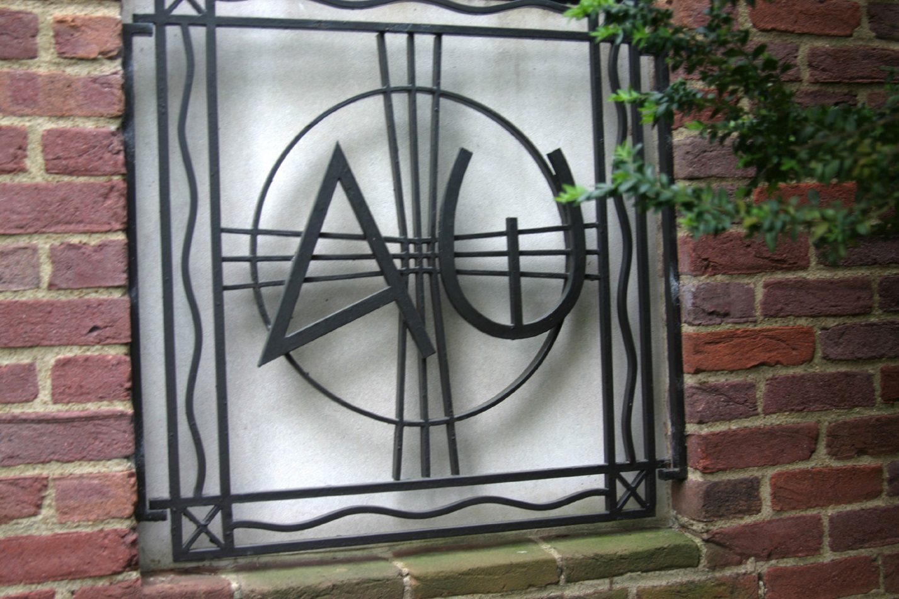

Title: The Alpha and Omega Date: 1960 Building: Vanderbilt University, Divinity School Town: Nashville, Tennessee Object: Metal Work

More about the Artwork: "It is done! I am the Alpha and the Omega, the beginning and the end. To the thirsty I will give water as a gift from the spring of the water of life." This ironwork symbol created by an artist in 1960 as part of the exterior decoration of Benton Chapel at Vanderbilt University, offers a multi-layered vision of the twenty-first first chapter of Revelation. The letters that stand as the beginning and end of the Greek alphabet are prominent, supported by a cross and circle that represent Christ's universal nature. On the four sides are single wavy strands that recall the water of life, surrounding the world.

Title: ***The Man Who Walked Between*** the Towers by Mordicai Gerstein

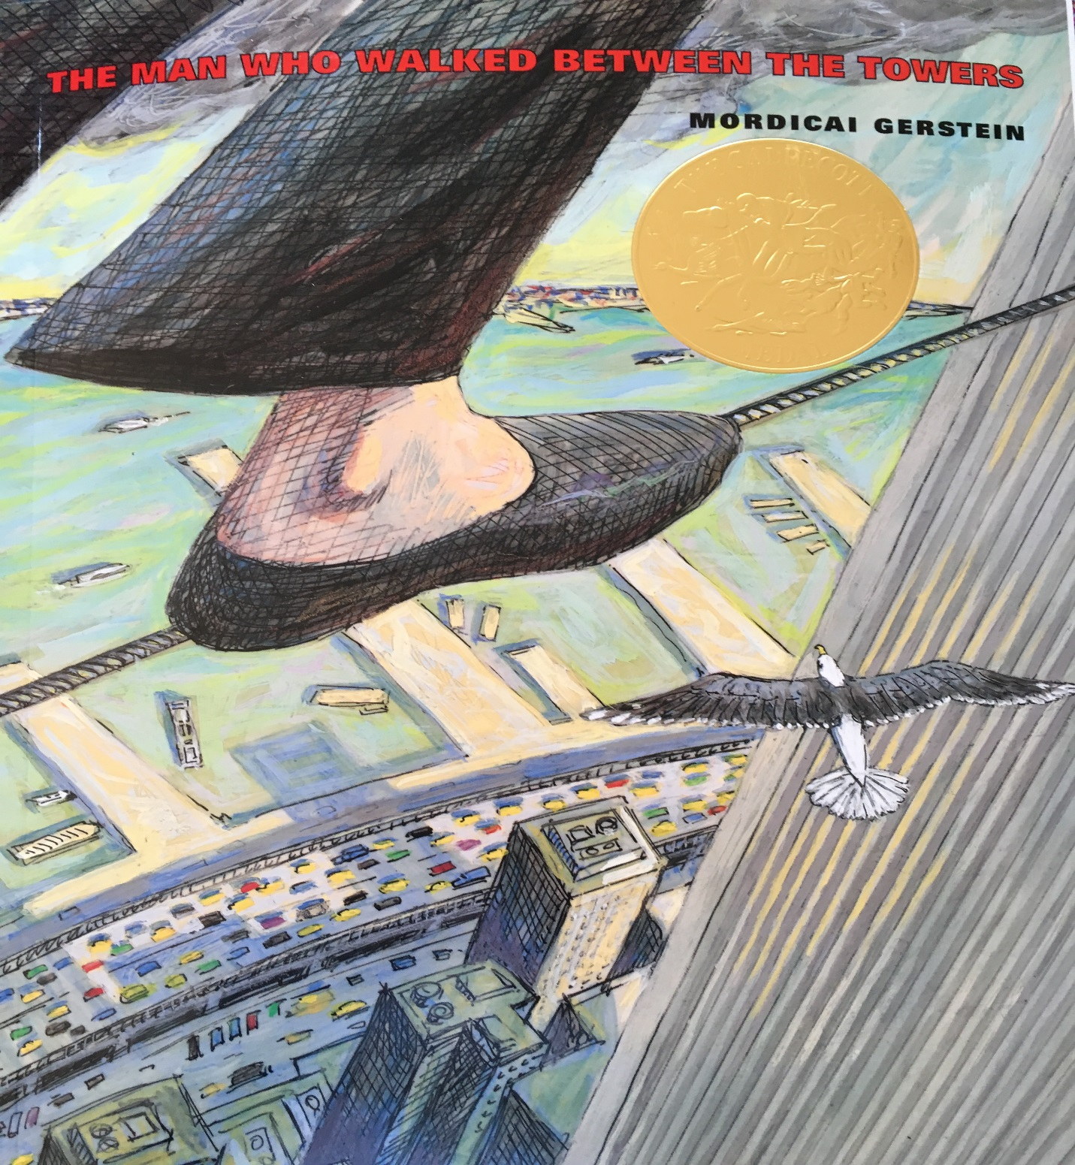

**Key verse: Jesus answered, "My kingdom does not belong to this world.  
If my kingdom did belong to this world,**

**Gospel** [**Jn 18:33b-37**](http://www.usccb.org/bible/john/18:33)

Pilate said to Jesus,  
"Are you the King of the Jews?"   
Jesus answered, "Do you say this on your own  
or have others told you about me?"   
Pilate answered, "I am not a Jew, am I?   
Your own nation and the chief priests handed you over to me.   
What have you done?"   
Jesus answered, "My kingdom does not belong to this world.  
If my kingdom did belong to this world,  
my attendants would be fighting  
to keep me from being handed over to the Jews.   
But as it is, my kingdom is not here."   
So Pilate said to him, "Then you are a king?"   
Jesus answered, "You say I am a king.   
For this I was born and for this I came into the world,  
to testify to the truth.   
Everyone who belongs to the truth listens to my voice."

Making the Connections for Catechists:

There are many strange similarities between Jesus in this gospel and Phillipe the young man in the story who walks between the two towers of the World Trade Center. Phillipe is a gifted tightrope walker that draws many crowds who are enthralled with his gift and the joy he finds in sharing it. Many crowds were drawn to Jesus. Jesus’s words, mission and message captivated the crowds. Jesus knew who he was, and in human ways shared a divine message, truth and indwelling. He too had a passion and purpose that was certain, true and mesmerized the crowds.

The law enforcers of the day could not understand the desire, passion and purpose of Jesus. He challenged their laws and their lies to a higher truth and law. The law and the way of love. Phillipe had a desire he could not contain and could not be understood by the local authorities. In both cases the local authorities were trying to do their job. They couldn’t see that Jesus as Phillipe would teach people to value something that couldn’t be seen and both risked their lives to do so.

In Jesus day the temple was the biggest building in all of the land. People of different cultures throughout time communicate to the world what is most important to them through the biggest and tallest buildings that they build. In medieval Europe the cathedrals pointed out to everyone that God was the most important to them, that era is referred to as Christendom. So from the Jewish temple in Jerusalem, to the cathedrals of Europe, the United States built two buildings that spoke to the world what was most important to it as a country. The World Trade Center functioned as a financial center for the whole world. Whether we like it or not our greatest value that we were telling the world was money. Out tallest buildings told the whole world our truth whether we could tell it to ourselves or not.

Whoever would of thought in modern times that those buildings could be destroyed. Today in the gospel Jesus tells of a kingdom that the world can’t yet understand. This kingdom is not here and it doesn’t need kings. It is the kingdom of truth and love. It is the kingdom of belonging and listening to the Spirit of the King, our God and Creator. The Holy Spirit lives within our hearts and desires us to build the kingdom of God wherever we find ourselves. It is a kingdom that can’t be destroyed, it is forever.

Long after the world trade centers are gone, the memory of the day that someone captivated the world through walking on a rope between the two towers lives on. The temple in Jerusalem is gone, the cathedrals of Europe for the most part remain but many are empty of life and love. This gospel story challenges us to live lives with a lasting purpose. To live lives fully developing our God given gifts and talents. When we do this we please God. We become disciples that bear lasting fruit with our lives. The gift in our abundant lives multiplies in the seeds that are scattered. Maybe this is what it means to live and to grow the kingdom of God. To live our truth and to share our gifts in love for the continued life and nourishment of the world. The will continue after we are gone, eternally. Like Jesus and Phillippe.

The difference between Phillipe is his passion was for his own fulfillment. Jesus’s passion was to risk his life so that a new way of loving and living would be established forever for the life of the world. Christianity lives and thrives all over the world. It looks like Jesus showed us the way. Through giving away our lives by sharing out talents we live on as Jesus has. This mystery gives meaning and remembrance long after our feet have trod on a wire or on the land, leaving behind a glimpse of life eternal.

Bullet Points for Parents:

* Phillippe the Man who walked between the towers had a purpose inside him that no one could understand. Jesus also had a purpose inside him that no one in his time could understand.
* Jesus and Phillippe both risked their lives to give life to their purpose.
* The authorities in both Jesus and Phillippe’s world found their purpose to disrupt greatly daily life and the ways of the current cultures.
* Phillippe and Jesus were both arrested for doing so.
* Phillippe was given a sentence to perform for children in Central Park. Jesus was given a sentence to death.
* Phillippe’s performances shared his joy with the crowds daily. Phillippe’s purpose and passion to walk between the towers is held in the memories of all of New York City. It gives a bit of wonder and joy in the midst of unimaginable loss in the destruction of on 9/11/01. This devastation lives with the people of New York every day. Phillippe’s memory can help point to a world beyond the loss. The buildings are gone but the memory of his risk and courage live on.
* Jesus taught the crowds daily and performed miracles. He pointed to a new way, an new world, one without end. The rulers and many people of the day were upset as Jesus turned upside down their status and securities. All that is gone now, but the life and way of Jesus, the kingdom of God continues to grow here on earth.
* Participating in the Kingdom of God here offers us a way like Phillippe and Jesus to share our gifts, love and talents for the life of the world, these acts will live on too.

**Making the Connections for Children:**

1. Do you ever get any big ideas to do something risky?
2. Whom would your idea serve?
3. Sometimes people do things for their own self glory, can you give some examples?
4. Sometimes people do things to serve others looking for no glory, can you give some examples?
5. How can you tell the difference between the two, what is lasting?
6. Jesus stood before the kings of the day but they called him a King. Did Jesus tell them he was a King, what was their evidence?
7. Jesus had a mission and purpose that guided him through many sufferings even death. He did this for others, for all. How did he serve the Kingdom of God as it’s King?
8. How was Phillippe will to serve the community with his sentence?
9. Jesus’ shows us that the way of the Kingdom of God is to be sacaficial. As the King of God’s Kingdom he shows it’s the way of laying down ones life for others. How did the saints and apostles do this? How might you be called to do the same in small and large ways.
10. What might be the results?

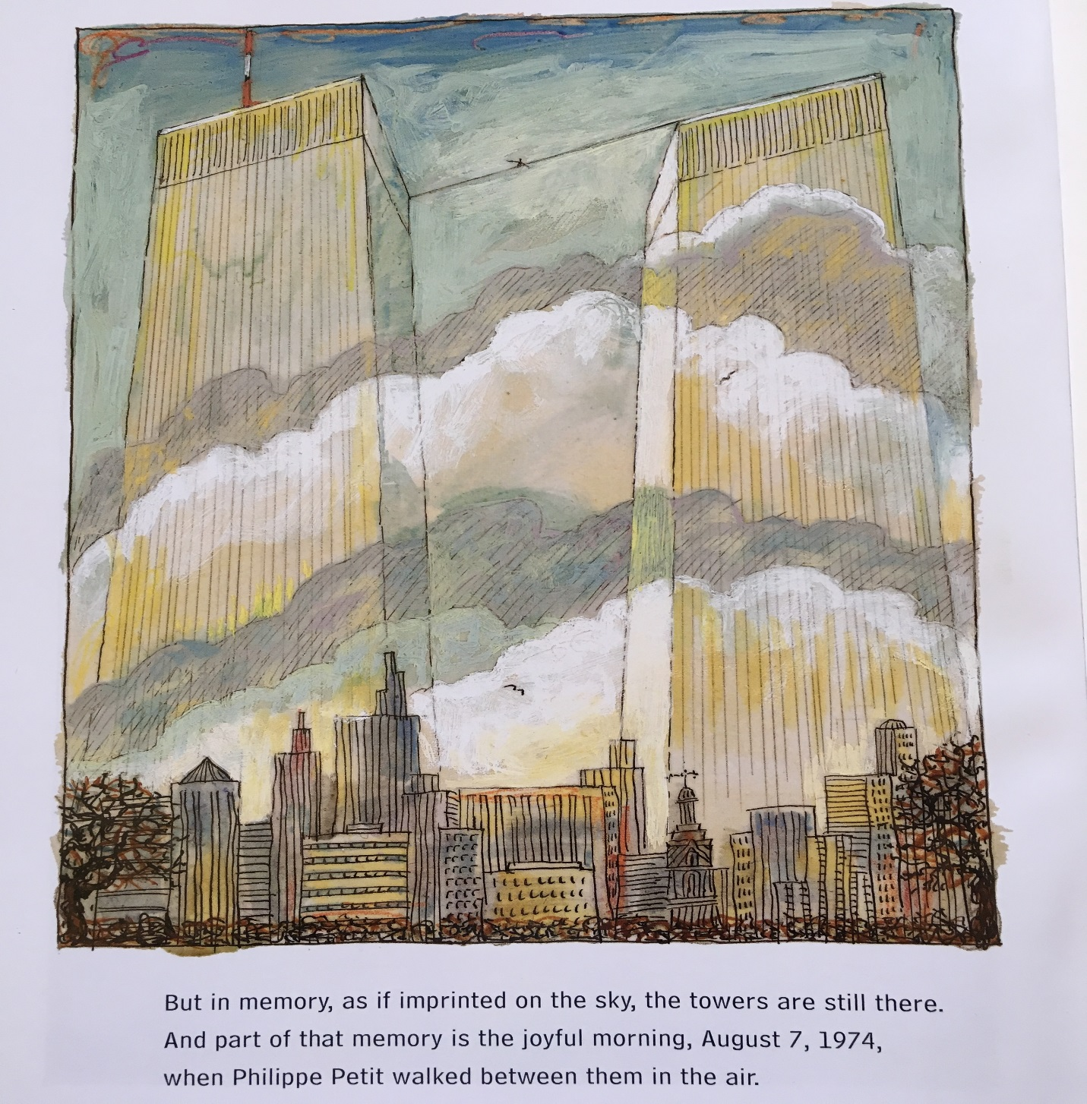

**Question of the Week:** What gift, passion or joy has God the Creator created in you to use to build the kingdom of God ? How is God asking you to offer your life to bear fruit that will last?

**Gospel Character Qualities:** **confidence in God strong identity**

**Suggested Family Activity:** Look for historical and contemporary examples of individuals who shared their passions and talents for others. Look for people who shared it for themselves. Help your family to identify qualities to discern the difference. Discuss what a difference living for the Kingdom of God makes.

**Biblical Background John 18:33-37 Cycle C The Feast of Christ the King**

**Cultural Geography:** Pilate’s palace in Jerusalem, a place called the praetorium. It is the place prisoners were brought before the ruler to be tried. A place where townspeople and leaders would gather and be able to look on.

**Terms:**

**King of Judeans:** Pilate is the governor of the Judean region but is a Roman and works for Rome who rules over the people including the Jewish people. Thus Pilate differentiates himself from Jesus as a ruler but not related to his kin, community his people. Jesus craftily does not answer the question but puts it back to Pilate is that what you call me implying he received that title from his people.

**Truth:** Jesus prefers to be known as “the one who gives witness to the truth”. Authority and power are not in a worldly title of concept. His authority comes from the source of truth, God the Creator. Jesus and his followers do not bow to a king in service, Jesus is here to serve one, the one that is Truth. There is one truth Jesus states therefor is you seek it you will find it. This offer goes out to Pilate as well.

**Pilate:** Roman ruler charged with overseeing the area of Israel at the time.

**Cultural Insights:** As citizens of the United States we struggle with the concept of king as it’s not in our culture. Jesus denied kingship in the political sense too. “The Feast of Christ the King was contributed to the church by the Franciscans. The Franciscans helped develop this observance called it “the feast of the absolute predestination of Christ,” Taking their cue from texts like Colossians 1:15, they reason that Chrsit was the firstborn of all creation. God who exists outside of time knows the existence of all creation at once. To create the first flesh and blood human in the divine image and likeness, God needed a flesh and blood model. Jesus incarnate was that model. This is how the Franciscans understood the kingship of Christ.” (John Pilch – The Cultural World of Jesus)

**Insight into Meaning:** Jesus is ushering in a new kind of kingship. One of unity of all people, therefore he does not let Pilate attach him to one group. Jesus belongs to the truth, the truth that is in all of Creation. He has come to awakened people to God’s life, “the truth” all around him that not just the Jews will have access to, but the God of creation is in all and God’s presence/truth is in all. This is the kingdom to which Jesus comes to set a fire to. This awakening to this truth is Christ Resurrected, the kingdom includes all of creation.