**Cycle A Mar. 1, 2020**

**The First Sunday of Lent**

**Title: BE STILL and Know the Power of God**

**Theme:** Yielding to The Spirit within us stills our fears so that God can use us to tame the wildness around us.

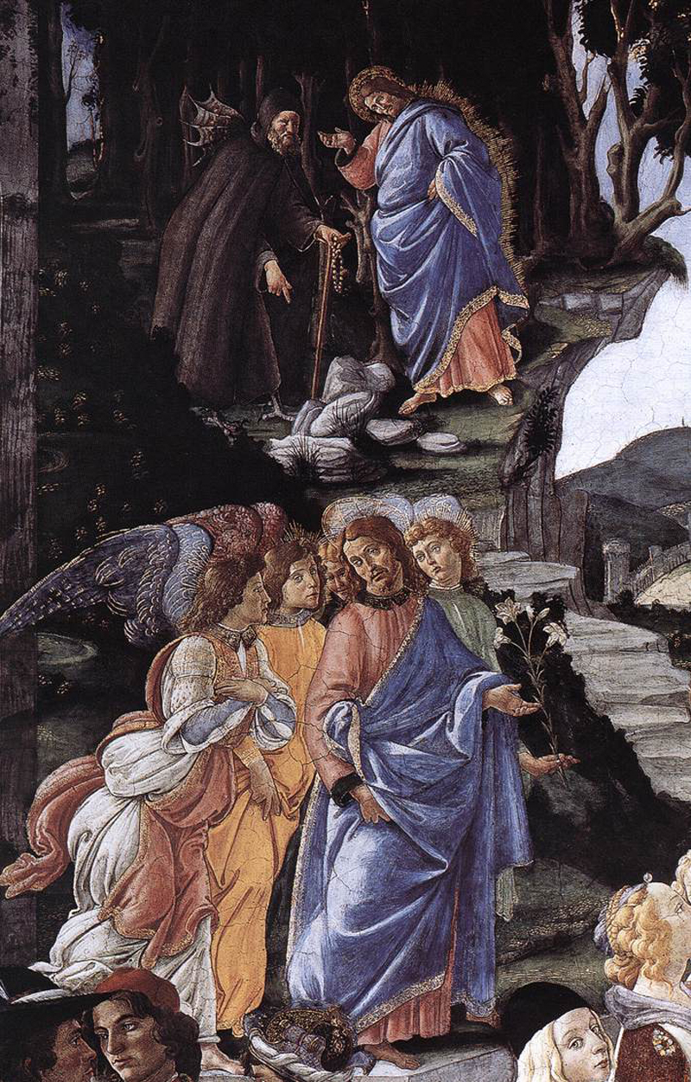

Title: Jewish Sacrifice and the Temptation of Christ Artist: Sandro Botticelli Medium: Painting Date: 1478-81 Building: The Sistine Chapel, Vatican City City: Rome Country: Italy

**Story:** Where the Wild Things Are Author and Illustrator: Maurice Sendak

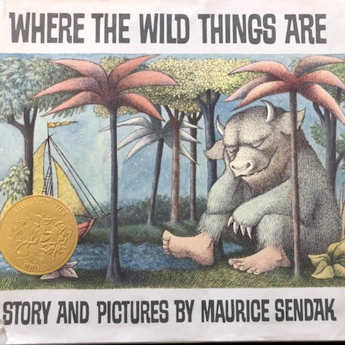

**Sunday Gospel:** Luke 4:1-13

**Key Verse: Jesus was led by the Spirit into the desert for forty days.**

*Filled with the Holy Spirit, Jesus returned from the Jordan   
and was led by the Spirit into the desert for forty days,   
to be tempted by the devil.  
He ate nothing during those days,   
and when they were over he was hungry.  
The devil said to him,  
“If you are the Son of God,   
command this stone to become bread.”  
Jesus answered him,   
“It is written,* One does not live on bread alone*.”  
Then he took him up and showed him  
all the kingdoms of the world in a single instant.  
The devil said to him,  
“I shall give to you all this power and glory;   
for it has been handed over to me,   
and I may give it to whomever I wish.  
All this will be yours, if you worship me.”  
Jesus said to him in reply,  
“It is written:*You shall worship the Lord, your God,and him alone shall you serve.*”  
Then he led him to Jerusalem,   
made him stand on the parapet of the temple, and said to him,  
“If you are the Son of God,  
throw yourself down from here, for it is written:*He will command his angels concerning you, to guard you*,  
and:*With their hands they will support you,lest you dash your foot against a stone.*”  
Jesus said to him in reply,  
“It also says,*You shall not put the Lord, your God, to the test.*”  
When the devil had finished every temptation, he departed from him for a time.*

Making the Connections for Catechists:

What’s important in this gospel reading is recognizing it’s the Spirit driving Jesus out into the desert to face the temptations. At first glance we might think that Jesus goes it alone out into the wilderness with very little resource. We will realize this is not true if we read what came right before this call out into the desert. Jesus was baptized by John in the Jordan. We read, “As Jesus was coming up out of the water, he saw heaven being torn open and the Spirit descending on him like a dove.” Mark 1:10. It is important to realize that the Spirit has everything to do with this call and arduous journey in Jesus’ life.

The word used in relation to the Spirit here is very strong and dramatic. Heaven was ‘torn’ open for the Spirit to descend on Jesus. And the Spirit ‘drove’ him out into the desert. Mark seems to be telling us that the Spirit can come into our lives in dramatic ways and can begin to work immediately, taking us places that we would not choose to go. Inviting us to think and act in ways that we never thought we would have the strength to do so.

In the story “Where the Wild Things Are”, our character Max takes a courageous journey of transformation just like Jesus does. Jesus faces many wild things in the desert that had to cause him a great deal of fear including Satan himself. They both learn to face the wild things with a weapon that the world would never think to offer, stillness. The story tells us, “Max came to a place where the wild things are and they roared their terrible roars and gnashed their terrible teeth and rolled their terrible eyes and showed their terrible claws till Max said, “BE STILL!” With that Max tamed the wild things and they were frightened and called him the “most wild thing of all”. They even made him King of the Wild Things.

Jesus also went into the desert alone and in silence to face all of his fears and temptations. In the stillness he discovered ‘the way’ of relying completely on the strength and guidance of the Holy Spirit. Jesus’ journey is one of transformation in which he moves from being anointed and called through baptism, to one empowered by the Spirit. As soon as he leaves the desert, John is arrested, and the mission of redeeming God’s people becomes his to fulfill. His very first words in the beginning of his public ministry are “The kingdom of God is at hand. Repent and believe in the gospel.”

Although Jesus and Max went on their adventures alone, they discovered they weren’t alone, and that they needed the support of others. For Jesus the angels ministered to him, for Max smelling the good things to eat reminded him of his mother’s love and care. For Max and for Jesus, “Perfect love castes out all fear’. The wild things tried to allure Max with a false love and adulation but Max knew his mother’s love was what was real. Jesus and Max each fought their spiritual battles and discovered the power of the God was within them on their own, but they then needed love and support to walk in God in their ministry.

God calls us into the desert this Lenten season by first reminding us that the Spirit of God is within us, and wants to work powerfully in our lives and in the world through us. After an encounter with God, everything else can still be the same in our families, with our friends. But inside we have changed; we have conquered our fears, our complacencies and our boredom. We now have a call and a purpose to begin to build the kingdom of God right where we are. We have all that we need within us through connecting with the Spirit of God. We can access the strength and power of the Spirit simply by remembering, to --- “Be Still”.

Bullet Points for Parents:

* We begin Lent every year with looking at this significant gospel story about the initiation of Jesus’ public ministry. It is most important that we recognize that it is the Holy Spirit is the initiator.
* Jesus had just been baptized by John, and the gospel writers use strong language in describing what Jesus experienced. As Jesus came up out of the water, he saw heaven being “torn” open. And then the Spirit ‘drove’ Jesus out into the desert.
* The Spirit has everything to do with this arduous journey Jesus is being called to.
* This gospel has significant implications for us as well, when the Spirit comes into our lives the movements can be strong and dramatic.
* In our story Max takes a courageous journey of transformation just like Jesus does.
* Jesus faces many wild things in the desert including Satan himself. Max also faces many wild scary monstrous beings.
* They both learn to face the wildness with an unworldly weapon, stillness.
* Max spoke to the wild things, “BE STILL”. “With that Max tamed the wild things and they were frightened and called him ‘the most wild thing’ of all. They even made him ‘king of the wild things’!
* Jesus also went into the silence to face all of his fears and temptations. In the stillness he discovered the ‘way’ of relying completely upon the Holy Spirit. This was the lesson and wisdom he would need to apply daily throughout his years of public ministry.
* Jesus and Max go out on their adventures alone. They both however discover that they are not alone. Angels ministered to Jesus, Max was reminded by the smells of his mother’s cooking of her nearness and love.
* Jesus and Max both discovered that their power to fight their spiritual battles resided within them. They also learned that they didn’t need to walk alone.
* After an encounter with God everything can look the same on the outside, but we are forever changed on the inside.
* The church gives us Lent to help us remember that our relationship in God is an inside job. We all have what we need within us to accomplish the call of God in our lives. We can access the same strength and power by remembering to be still.
* Like Jesus we share in this call to grow the kingdom of God through our baptism. Like Jesus we will be tested so we can grow strong. And like Jesus we will be given all we need. And if it’s anything like how it went for Max and Jesus, change is here and you will see it happen, on earth just as it is in heaven.

Making the Connections for Children:

1. Do you ever get sometimes need to take a time out?
2. What happened when you did? Where you changed by it?
3. Do you ever have wild dreams?
4. How do they make you feel? Do they sometimes feel real?
5. How did Jesus’ time out prepare him for how his life had changed?
6. What kind of preparation did Jesus need and how did he learn the lessons?
7. What did Max confront in his dreams?
8. How did Jesus and Max confront their fears? Where did their help come from?
9. How did their ‘time out’ and all they learned from it change them?
10. Could people tell they were changed when they returned?
11. How were they the same and yet different?
12. How are we called as Christians today to confront the wild things in our lives and world?
13. For what purpose did Max and Jesus confront the wild things? For what purpose are we being called to do the same thing?
14. How does the church offer us Lent as a time to take some time out, be still and discover what lies within us? How will that help us in our God given purpose?

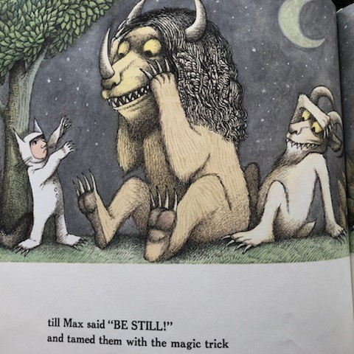

**Question of the Week:** What are some of your fears, talk about them with each other as a family. How can you replace your fears with faith? Pick one idea and work on it through-out Lent.

**Gospel Character Qualities: indwelling of the Holy Spirt Courage**

**Additional Family Activates: 1)** Brainstorm what kind of things we fear, who are the monsters and scary things in our lives. Get a large piece of poster paper. Trace your body on it, and then create a monster or a personification of something that you would be scared of in the desert. This can be an animal, a being or an experience, such as failure, being left out and etc. The point is to help children name their fears and encourage them that they can conquer their fears by slowing down, remembering they have the Holy Spirit within them and call upon to calm their fears and to fight their fears with faith. Create a mediation to a place of stillness and to practice calling upon the Holy Spirit to conquer their fears**. 2)** How can we as individuals and as families find time for stillness and prayer in Lent? Research the places in your state and diocese where people live and pray in silence. Talk about what it is like or show pictures of these places. How might you find silence and the “desert experience’ around you in your suburban and urban setting? How can you create a place of prayer and quiet in your home.

Biblical Background Cycle A The First Sunday of Lent Luke 4:1-13

**Geographical Setting:** The desert is in the Jericho area, 1000 feet below sea level, in proximity of Jerusalem which is 2500 feet above sea level. In this Gospel account Jesus is led by the Spirit into the desert near Jericho.  This desert is part of the great African rift valley that slices through the land of Israel from north to south.  In Jericho you are approximately 1000 feet BELOW sea level.  The desert lands that surround Jericho are harsh, barren, hot and forbidding.  The only way that Jesus will survive will be because God will provide for all of his needs.  The desert is a lonely place and the perceived haunt of demons, especially any that have been "casts out" of a host by a religious healer.  Those demons have to go somewhere and in the mind of the ancients the desert regions were their preferred location.  One would fully expect to meet a demon or two in the desert and Jesus is not disappointed.

Terms: **The spirit “drove**” - (forceful word), compelled, this is not something that one would normally do; the desert if filled with wild beasts, dangerous.

**John the Baptist** – 6 months older than Jesus, cousins who knew each other well. John arrested by **Herod** who will have him beheaded later in gospel. Herod is the bloodthirsty evil king of Israel appointed by Rome. He is half Jewish and half Edomite. Jesus goes to great means to get out of Herod’s reach. Jesus opens ministry with same words of John

**Repent**– turn around and come back to God

**Cultural Insights:** In the verse before our Gospel opens with a voice from heaven was heard proclaiming, "This is my Son, whom I love; with him I am well pleased".  This was a public claim to honor that cannot go unchallenged.  In the time of Jesus every public claim to honor has to be tested to prove it true.  Therefore it makes perfect sense that Jesus was lead into the desert where he will be tested (tempted) by the Devil.  The Devil is the enemy of God and God's plan of salvation for all men and women.  He has to challenge the claim of honor made about Jesus by the Father.  He will try to induce the "Son" to sin and in the process feel the same of alienation and separation from God. .  Jesus would be honored by his disciples for the fearless way that he entered into this time of challenge.

**Insight into Meaning:** Note that Jesus would have been tempted for the entire period of forty days.  In the Biblical world forty is an important number.  Moses was on the mountain with God for forty days.  The Israelites wandered in the deserts for forty years.  Jesus will be tempted for forty days and will best the Devil in the end.  Jesus shares with his disciple’s only three specific temptations rather than a list of all the times the Devil tried to seduce him to sin. The Devil tries to tempt Jesus to change his mind, to throw away his life and finally to accept a bribe to forgo his role as the Messiah.  These three "types" of temptations correspond to the daily prayer of every Jewish person.  Jewish people pray each day that they will be able to love the Lord their God with their whole heart (the Biblical mind/heart space is combined), with their whole soul which means their life and with all their strength which roughly translates to what your mind and body combined produce, your bank account.  The Devil tempts Jesus in each of these areas and lost in the exchange each time.

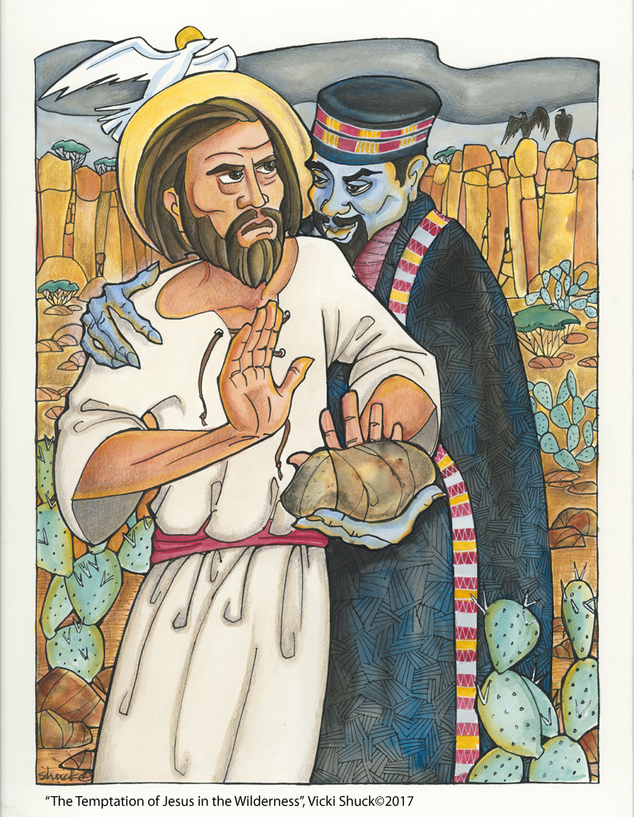

**The Temptation of Jesus in the Wilderness by Vicki Shuck, 2017**

Background on art

|  |
| --- |
| pope Sixtus IV commissioned Botticelli along with other artists to decorate the walls of his new papal electoral chapel ("Sistine" Chapel, after "Sixtus".) Botticelli painted three frescoed sections of the walls, one of which was "Jewish Sacrifice and the Temptation of Christ."  In 1475, the Dominican practice of the rosary was revived in Germany and quickly became widespread among Dominicans, Benedictines, and Carthusians. Pope Sixtus IV, a Franciscan who served from 1472-1484, also encouraged the practice through papal bulls and indulgences.  The devil in Botticelli's painting wears clerical garb and carries rosary beads, a clear contemporary reference to the new rosary practices, which carried with them the promise of remission of punishment for confessed sins through indulgences. This fashioning of the devil as an active, practicing cleric was a popular motif in Temptation-themed art of the period. What it signifies is less clear; does the rosary indicate that, with Mary's intercession and Christ's grace, even the devil can be saved? Or is it a less benign fashioning, indicating that the devil is very clever and can disguise himself in the garb of the faithful?  "Christ's threefold temptation by the Devil, as described in the Gospel according to St Matthew [ACT note: the Lukan version differs in the order of the temptations and the closing section, but is essentially the same otherwise], can be seen in the background of the picture, with the Devil disguised as a hermit. At top left, up on the mountain, he is challenging Christ to turn stones into bread; in the centre, we see the two standing on a temple, with the Devil attempting to persuade Christ to cast Himself down; on the right-hand side, finally, he is showing the Son of God the splendour of the world's riches, over which he is offering to make Him master. However, Christ drives away the Devil, who ultimately reveals his true devilish form. On the right in the background, three angels have prepared a table for the celebration of the Eucharist, a scene which only becomes comprehensible when seen in conjunction with the event in the foreground of the fresco.  The unity of these two events from the point of view of content is clarified by the reappearance of Christ with the three angels in the middle ground on the left of the picture, where He is apparently explaining the incident occurring in the foreground to the heavenly messengers. We are concerned here with the celebration of a Jewish sacrifice, conducted daily before the Temple in accordance with ancient custom. The high priest is receiving the blood-filled sacrificial bowl, while several people are bringing animals and wood as offerings. At first sight, the inclusion of this Jewish sacrificial scene in the Christ cycle would appear extremely puzzling; however, its explanation may be found in the typological interpretaion. The Jewish sacrifice portrayed here refers to the crucifixion of Christ, who through His death offered up His flesh and blood for the redemption of mankind. Christ's sacrifice is reconstructed in the celebration of the Eucharist, alluded to here by the gift table prepared by the angels." [from *Sandro Botticelli, 1444/45-1510*, by Barbara Deimling. Taschen, rev. ed., 2000, pg. 34-35.] |
| 1478-1481 |
| Botticelli, Sandro, 1444 or 5-1510 |

Background on Children’s Story – *Where The Wild Things Are*

by Maurice Sheldak

* Pub. Date: November 1988
* Publisher: HarperCollins Publishers
* Format: Hardcover, 48pp
* Sales Rank: 893
* Age Range: For infants or children in preschool
* ISBN-13: 9780060254926
* ISBN: 0060254920
* Edition Number: 25
* Edition Description: 25th Anniversary Edition

**Synopsis**

Max is sent to bed without supper and imagines sailing away to the land of *Wild Things,* where he is made king.

**SLJ**

Each word has been carefully chosen and the simplicity of the language is quite deceptive.

**Biography**

Sometimes dark, sometimes gleefully silly, but always inventive, intelligent, and colorful, Maurice Sendak’s imaginatively illustrated children’s books never forget their audience. Although his classic *Where the Wild Things Are* was criticized upon its initial publication for being too frightening, children responded with enthusiasm to both its wonderfully zany artwork as well as to its honesty. Forty years later, they still do.

**Also Known As:**  
Maurice Bernard Sendak (full name) **Current Home:** Brooklyn, New York **Date of Birth:** June 10, 1928

**Place of Birth:**  
Brooklyn, New York **Education:** Art Students' League

**Awards:**  
Caldecott Medal, 1964 (for *Where the Wild Things Are*); Hans Christian Andersen International Medal, 1970; Laura Ingalls Wilder Award, 1983; Jewish Cultural Achievement Award, 1988; National Medal of Arts, 1996

**Biography**

"I never wrote a book where I taught a lesson," Maurice Sendak once bragged in an interview. Fans of his lyrical, lushly illustrated picture books know Sendak has a far more important mission. Rather than instructing his young readers in proper manners, the man who's been called "the Picasso of children's books" has been a vital, expressive voice for children's feelings.

Sendak first honed his art as an illustrator for writers like Ruth Krauss and Else Holmelund Minarek. He explored different styles of drawing and painting, influenced by sources as diverse as William Blake, Randolph Caldecott and Walt Disney.

In the '50s and early '60s, Sendak began to write his own books, and to forge his own distinctive visual style. The most popular of the works produced in what he later called his "apprenticeship period" was *The Nutshell Library*, a collection of four tiny books (2 1/2 by 4 inches wide) that was instantly and enduringly popular.

His first mature work, *Where the Wild Things Are* (1963), was a watershed both in Sendak's career and the history of children's literature. It tells the story of a boy named Max, whose mother sends him to his room without supper, calling him a "wild thing." Max makes an imaginary journey to a land of monsters, where he's crowned King of All Wild Things. But his longing for comfort and security return him at last to his room, where he finds his supper waiting for him. Some adults were dismayed by the book's ferocious-looking monsters and its belligerent young hero. "It is not a book to be left where a sensitive child may come upon it at twilight," one librarian cautioned.

Despite the warnings, *Where the Wild Things Are* was a huge commercial success, and was awarded the prestigious Caldecott Medal in 1964. In his acceptance speech, Sendak seemed to address his critics when he said that despite adults' desires to protect children from "painful experiences," the fact is "that from their earliest years children live on familiar terms with disrupting emotions, that fear and anxiety are an intrinsic part of their everyday lives, that they continually cope with frustration as best they can. And it is through fantasy that children achieve catharsis. It is the best means they have for taming Wild Things."

In the following years, Sendak illustrated dozens of books, and wrote and illustrated several more of his own, including *In the Night Kitchen* (1970) and *Outside Over There* (1981), which he considered to be the second and third parts of a trilogy that began with *Where the Wild Things Are.* A lover of theatre, he has also designed and produced numerous operas, plays and ballets.

Though his work has sometimes been controversial, Sendak is now renowned for his ability to recall, depict and transform the painful realities of childhood into what John Gardner, reviewing one of Sendak's books, called "not an ordinary children's book done extraordinarily well, but something different in kind from an ordinary children's book: a profound work of art for children."

**Good to Know**

**In 1948, Maurice Sendak** and his brother Jack took six model toys to the toy store F.A.O. Schwarz, which they hoped would commission a set. The store turned down the toys, but offered Maurice a job as a window display designer, which he took.

**Sendak wrote** *Higglety Pigglety Pop! Or, There Must Be More to Life*, in tribute to his beloved dog. The book's protagonist, like Sendak's pet, is a Sealyham terrier named Jennie. Years later, Sendak got a German shepherd, who already had a name when he adopted it. The dog was named Max, just like Sendak's most famous character.

**From Barnes & Noble**

Max is being so terrible that his mother sends him to his room without supper. But Max doesn't care -- he sails off to the land of the Wild Things, and they make him his king. There, Max can be as terrible as he pleases, and the Wild Things join in the rumpus. Finally, Max is tired of being wild, and yearns to go home. Marvelous pictures and the superb story combine to make this a quintessential picture book. In it, readers will recognize their own wild side.

**From the Publisher**

Max is sent to bed without supper and imagines sailing away to the land of *Wild Things,*where he is made king.

**SLJ**

Each word has been carefully chosen and the simplicity of the language is quite deceptive.

**Children's Literature**

Sendak presents an image of children not as sentimentalized little dears but as people coping with complex emotions such as anger, fear, frustration, wonder, and awareness of their own vulnerability. Max feels anger at his mother, acts out his aggression in a fantasy land as he becomes "king" of his wild and ungovernable forces, and returns hungry, sleepy, and peaceful to the real world, where his porridge is still hot. This is a well-earned and reassuring happy ending for all children wrestling with human nature's darker emotions. It is also available in Spanish.

Loading...



**Product Details**

* Pub. Date: November 1988
* Publisher: HarperCollins Publishers
* Format: Hardcover, 48pp
* Sales Rank: 893
* Age Range: For infants or children in preschool
* ISBN-13: 9780060254926
* ISBN: 0060254920
* Edition Number: 25
* Edition Description: 25th Anniversary Edition



**This item Rated Appropriate for Ages 2 and Up**



[Download Flash to see more](http://www.adobe.com/shockwave/download/download.cgi?P1_Prod_Version=ShockwaveFlash)

[About Common Sense Ratings](http://www.barnesandnoble.com/help/help_cds2.asp?pid=32683)

**Why We Rated This Appropriate for Ages 2 and UP**

**What to watch out for**

**What Parents Need to Know**

About Where the Wild Things Are

Parents need to know that, though Max misbehaves, the message is one of parental love. This subtle masterpiece of story, writing, and art will have kids asking for repeated readings. Colorful language and a world of imagination make this wild adventure a fun learning experience.

* Families can talk about Max's behavior. Why does Max act the way he does?
* If he loves adventure so much, why does he go back to his parents?