Cycle C Sept. 22, 2019

The 26th  Sunday in Ordinary Time

Title: Crossing Sides

Spirituality Theme: Stars of God know how to be Belong on Both Sides.

**[Saint Malo monument of Clasped Hands.
 Tristram, Derek

Click to enter image viewer

Use the Save buttons below to save any of the available image sizes to your computer.
](http://diglib.library.vanderbilt.edu/diglib-viewimage.pl?SID=20130922701232910&code=&RC=55598&Row=&code=act&return=act)**

## 

Title: Saint Malo monument of Clasped Hands Date: 1997 Artist: Derek Tristram

Object: Freestanding Sculpture Place: Corbiere, France

|  |  |
| --- | --- |
|  |  |

|  |  |
| --- | --- |
| **Notes**  **On art:** | "During the morning of Monday April 17th 1995 whilst on passage from Jersey to Sark, the French catamaran "Saint-Malo" struck a rock 900 metres north of La Corbière Lighthouse. All 307 passengers and crew were saved from the partially submerged vessel. This memorial is erected in thanksgiving and as a tribute to the rescue, which with the help of God and of many strong arms, ensured the safe return of all on boat |

Story*: Chamelia and the New Kid in Class* by Ethan Long



Sunday Gospel: The Rich Man and Poor Man, Lazarus

#### Gospel [LK 16:19-31](http://www.usccb.org/bible/readings/bible/luke/16:19)

**Key Verse: Abraham replied, 'My child, remember that you received  
what was good during your lifetime while Lazarus likewise received what was bad;  
but now he is comforted here, whereas you are tormented.**

Jesus said to the Pharisees:  
"There was a rich man who dressed in purple garments and fine linen  
and dined sumptuously each day.  
And lying at his door was a poor man named Lazarus, covered with sores,  
who would gladly have eaten his fill of the scraps  
that fell from the rich man's table.  
Dogs even used to come and lick his sores.  
When the poor man died,  
he was carried away by angels to the bosom of Abraham.   
The rich man also died and was buried,  
and from the netherworld, where he was in torment,  
he raised his eyes and saw Abraham far off  
and Lazarus at his side.  
And he cried out, 'Father Abraham, have pity on me.   
Send Lazarus to dip the tip of his finger in water and cool my tongue,  
for I am suffering torment in these flames.'  
Abraham replied,  
'My child, remember that you received  
what was good during your lifetime   
while Lazarus likewise received what was bad;  
but now he is comforted here, whereas you are tormented.  
Moreover, between us and you a great chasm is established  
to prevent anyone from crossing who might wish to go  
from our side to yours or from your side to ours.’  
He said, 'Then I beg you, father,  
send him to my father's house, for I have five brothers,  
so that he may warn them,  
lest they too come to this place of torment.'  
But Abraham replied, 'They have Moses and the prophets.  
Let them listen to them.'  
He said, 'Oh no, father Abraham,  
but if someone from the dead goes to them, they will repent.'  
Then Abraham said, 'If they will not listen to Moses and the prophets,   
neither will they be persuaded if someone should rise from the dead.'"

Making the Connections for Parents and Catechists:

Can you think of examples when being the best feels the worst? That is what both of our stories are getting at today. In our gospel story Lazarus and the rich man live in close connection to each other. The rich man at a richly filled banquet table, and the poor man at his door, begging to be allowed to eat just the scraps on the floor. The story implies that the rich man ignored the vulnerabilities and needs of Lazarus who was in his path every day.

In our story Chamelia is use to being the star of the class. All the attention is usually centered on her. She is well liked and her classmates find her quite entertaining. One day it all changes. A new kid comes to the class, Cooper. All the kids stop watching and listening to Chamelia as they are intrigued in discovering who Cooper is. Chamelia does not like this, she is not use to having to share the attention. Probably a lot like the rich man in our gospel story.

In both stories the characters are present in each other’s daily life and are making things quite uncomfortable for “the stars”. Chamelia and the rich man share in a very comfortable position of prestige, status and life in the lime light. They thrive on it. Jesus calls us to a new way through this story. He is addressing the Pharisees. The Pharisees were religious leaders and law makers in the day of Jesus. They enjoyed very comfortable lives and often turned a blind eye to the poor. In this story Jesus wants to shake them up as a means to heal them from their self-imposed blindness and hardness of heart. He hopes that they might repent and turn their hearts around before it is too late.

God’s Kingdom points to the way of compassion and mercy. Jesus wants to make the point that both characters cry out from the depths of their hearts. Lazarus cries out, “I will be satisfied with the scraps of your table.” And after they die, the rich man cries out to Abraham to send a servant/beggar Lazarus, to “please give me just a drop of water for my thirst.” Jesus wants no one to feel the deep pain of exclusion. A life of isolation creates a great deal of pain, both now and in life ever after. We have all been there and it hurts. Studies show babies can die from a lack of touch. On the other hand when we work to manipulate or cheat in order to win it also hurts us and others deeply. We become a fool. As best described by Chamelia when she declares, “when being the best, feels the worst”. The rich man discovered this as well.

The way of Jesus invites us to be a true star by opening up our hearts to friendship with whoever is on the other side. Additionally, we are called to cross sides in extending the hand of friendship to those who are alienated. Jesus demonstrates this way to the Pharisees of being a star for God. They think they are God’s Superstars, as they can’t seem to get off the stage.

In the end Jesus did what the rich man asked for, Jesus crossed over through death to the resurrected life, so that we might all be able to do the same. He is our Super Star. Through Jesus even death cannot divide us from each other, he built the most important bridge in the world for us all. Now how might we work for Jesus in offering compassion and mercy to those on the other sides in life? In crossing sides we become true stars. We shine God’s love and grow more friends. As we participate in building bridges in the world, we grow light shining God’s love more brightly in this world. Chamelia and Cooper both cross sides to reach out in friendship to each other, we too are called to do the work of ‘crossing sides’.

**Bullet Points for Parents:**

* Both of stories today illustrate when being the best makes you feel the worst.
* In the times of Jesus like today, people of extremes lived and walked side by side each other. The story of Lazarus and the rich man illustrate this in the time of Jesus. The story of Camelia and Cooper illustrates this for children when children are made uncomfortable when they have to choose sides.
* What Jesus wants us to wake up to is how we extend ourselves to those in places of vulnerabilities? This will define us and affect our lives and it’s outcome. Jesus wakes people up to eternal values as a higher good.
* In the values of the world the Rich Man and Camelia are the super stars. They thrive on their status and take advantage of it.
* It’s important to note that Jesus is directing his message to the Pharisees, the superstars of the day, the religious leaders.
* The Pharisees enjoyed very comfortable lives and often turned a blind eye to the poor. In this story Jesus wants to shake them up to a new way as a means to heal them from their self-imposed blindness and hardness of heart. He hopes that they might repent and turn their hearts around before it is too late.
* Jesus wants no one to feel the deep pain of exclusion. A life of isolation creates a great deal of pain, both now and in life ever after. We have all been there and it hurts. Studies show babies can die from a lack of touch.
* On the other hand when we work to manipulate or cheat in order to win it also hurts us and others deeply. We become a fool.
* The way of Jesus invites us to be a true star by opening up our hearts to friendship with whoever is on the other side.
* In the end Jesus did what the rich man asked for, Jesus crossed over through death to the resurrected life. So that we might all be able to do the same. He is our Super Star. Through Jesus even death cannot divide. Now how might we cross sides to build bridges of faith, love and unity as Jesus did? We will grow more friends, those are the values of the kingdom of God.

Making the Connections with the Children:

Making the Connections with the Children:

1. When does being the best feel the worst?
2. How does that work for the rich man and Chamelia?
3. How does it work for Lazarus and Cooper?
4. Have you ever felt excluded?
5. What kind of change is Jesus calling for in the gospel story?
6. What happens when Chamelia shows compassion and mercy with Cooper?
7. When a bridge of love and friendship is built between them how does that change the whole classroom?
8. Where is there an example in our world, our neighborhood, our classrooms, our families, and our parish that if we would cross over and reach out in mercy and compassion it would really bring change?
9. How would that make us God’s stars?
10. What are ways we might cross sides to build a bridge of love and friendship through offering care and connection to someone who is on the other side?
11. What does Pope Francis have to say about this?

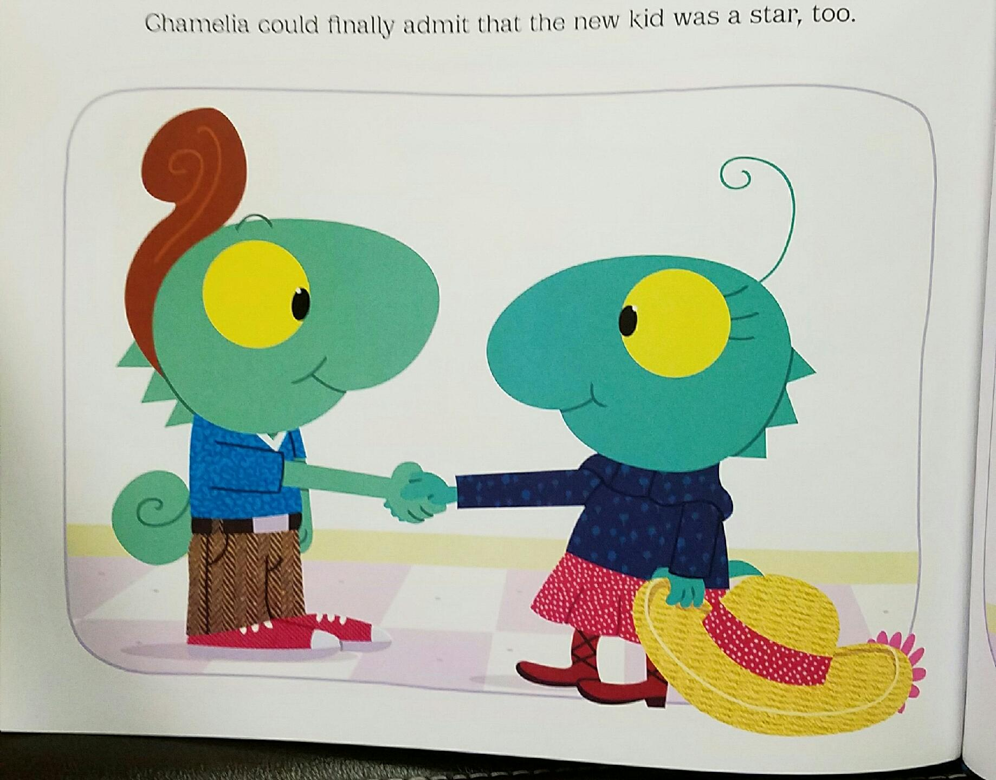

**Question of The Week:** Who do we experience in our everyday lives who is someone on the other side? Brainstorm ways as a family you can cross over to the other side and build a bridge of friendship and care.

**Gospel Qualities: Compassion Courage**

**Additional Family Activity:** Buy a big package of water bottles to put in your car. Practice offering them to people you pass by on the streets who are in need with a prayer attached for them. Make it a practice to pray for them daily. Learn more about the reality of homelessness and how it happens for people. Visit some shelters in the area and pray as a family if there is a way to get involved.

**Cycle C - Biblical Background The 26th Sunday of Ordinary Time**

**Geographical Setting:**

The setting would be a very nice home in a village.  The Rich Man would be assumed to own the largest home in the local area.

**Terms:**

**Rich Man -** a man who relates to his riches in a manner that is not consistent with the plan of God.  God blesses so that you can be generous to others.  This man is a "straw man" created by Jesus to represent someone who is not aware of the needs of others.

**Purple** - the color of the very wealthy.  It is very difficult to produce the color purple as a dye agent.  The process takes time and is the result of milking, one drop at a time, the purple dye from the Murex snail.  Millions have to be harvested to create a vat of die and each one is smaller than you finger nail.  Once the dye is used on wool or cotton it is subjected to sunlight and the color is set.  This is where we also get royal blue and red colors on fabrics.  These are also associated with royalty as is purple.

**Abraham's Side (the bosom of Abraham)** - a Jewish way of saying that the character died and went to heaven where he would be comforted by Abraham who God called his friend.

**Moses and the Prophets** - this is a Jewish way of referring to all the books in the Hebrew Bible.  The first five, the Torah, are thought to have been authored by Moses.  The rest of the collected books are called "the Prophets" because the authors speak the Word of God.  Note that means that Ruth and Esther are also prophets in this classical Biblical sense.

**Cultural Insights**

*"living in luxury everyday*" - what happened to the Sabbath?  It appears that this character in the parable does not honor God by taking the time to move out of ordinary life for all day, all week.

*"at his gate was laid a beggar*" - this man was not a beggar but rather a man to whom people coming and going into the house of the Rich Man could give alms.  He was alms worthy and would be placed in this position by his family.  Jewish people are required to pray twice daily, fast one day a year and give alms to any alms worthy person they see every day.  This fellow served this purpose in the village.  He would have been known by all.

*"dogs"* - considered dangerous and not kept as pets in the Biblical period.  They are feral and find food that is discarded in the area as they roam about at night.  The beggar would normally be terrified by such animals.  This point was a shock element to wake people up to stories’ impact.

*Rich Man* – from the other side he still tries to give commands to Abraham.  He just does not get it.  All his wealth has not revealed to him a need for God and the requirement to serve God.

**Insight into Meaning:**

Moses and the Prophets are enough.  The message of salvation that comes to us through the Bible is sufficient.  It is all we need to know how to live in right relationship with God. The Ten Commandments direct us to love and care for others.  There is no directive to offer sacrifice to God but rather to take care of our relationship with God and then let that relationship direct us in our love and concern for others. Jesus seems to teach that in the afterlife there is a state of torment.  Isolation brings about torment both now and in the afterlife. Again, Jesus is pointing out that when wealth in this life that doesn’t engage in the care of those in need it will bring isolation in this life and the next. Building bridges and crossing over division grows the kingdom of God. There is a great purpose that Jesus is speaking of here, that of acknowledging our need for God no matter what we have or don’t have, and being awake and willing to be provisional for the needs of those who lack. That keeps us all cared for, safe and comforted. Both in this life and the next Jesus seems to be making things clear here.