**The 28th Sunday of Ordinary Time**

**Oct. 11, 2015**

**Title: Jesus invites us to True Riches**

**Theme: Jesus Invites us to a life of value, versus one filled with valuables.**

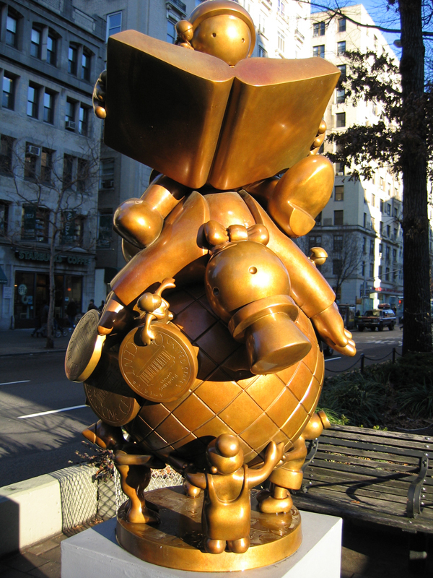

**name: Educating The Rich on the Globe Artist: New York sculptor, Tom Otterness Date: 1997 Place: along upper broadway in NYC, a number of his pieces poke fun at the cities drive to make money**

**More on the Artist:** Tom Otterness is a sculptor of sizeable reputation. His robust group of new sculptures (2004-2005) that graced five miles of the New York City Broadway 60th and 168th Streets is the result of years of planning and preparation. He may also be one of the most humorous contemporary public sculptors living today...His larger than life-size bronzes have taken root all over the United States in public and civic spaces. Otterness elevates the goofy in high-priced bronze works that are also endearing. You want to like these goofy characters, and they are likeable, but not easy like a Disney character. In his art exhibit in New York on Park Avenue in 2005, Otterness' sculptures about money dominated the streets. "Free Money", two goofy figures with turtle-like bodies embrace in a dance on a huge money bag that appears to be stuffed with money. Another sculpture in this parade of sculptures that bears the theme of money is a giant penny being pushed by little bronze characters." (Klein,

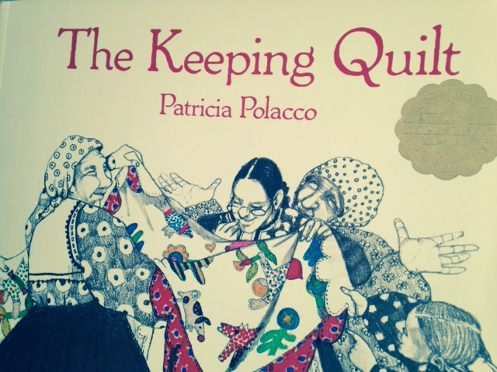

**Story: *The Keeping quilt***

**by Patricia polocco**

**Sunday Gospel**

**Key Verse: "We have given up everything and followed you."   
Jesus said, "Amen, I say to you,  
there is no one who has given up house or brothers or sisters  
or mother or father or children or lands  
for my sake and for the sake of the gospel  
who will not receive a hundred times more now in this present age:**

**Gospel** [**Mk 10:17-30**](http://www.usccb.org/bible/mark/10:17)

As Jesus was setting out on a journey, a man ran up,  
knelt down before him, and asked him,  
"Good teacher, what must I do to inherit eternal life?"  
Jesus answered him, "Why do you call me good?   
No one is good but God alone.  
You know the commandments: *You shall not kill;  
you shall not commit adultery;  
you shall not steal;  
you shall not bear false witness;  
you shall not defraud;  
honor your father and your mother*."   
He replied and said to him,  
"Teacher, all of these I have observed from my youth."  
Jesus, looking at him, loved him and said to him,  
"You are lacking in one thing.  
Go, sell what you have, and give to the poor  
and you will have treasure in heaven; then come, follow me."   
At that statement his face fell,  
and he went away sad, for he had many possessions.  
  
Jesus looked around and said to his disciples,  
"How hard it is for those who have wealth  
to enter the kingdom of God!"   
The disciples were amazed at his words.  
So Jesus again said to them in reply,  
"Children, how hard it is to enter the kingdom of God!   
It is easier for a camel to pass through the eye of a needle  
than for one who is rich to enter the kingdom of God."   
They were exceedingly astonished and said among themselves,  
"Then who can be saved?"  
Jesus looked at them and said,  
"For human beings it is impossible, but not for God.   
All things are possible for God."   
Peter began to say to him,  
"We have given up everything and followed you."   
Jesus said, "Amen, I say to you,  
there is no one who has given up house or brothers or sisters  
or mother or father or children or lands  
for my sake and for the sake of the gospel  
who will not receive a hundred times more now in this present age:  
houses and brothers and sisters  
and mothers and children and lands,  
with persecutions, and eternal life in the age to come."

Making the Connections for Parents and Catechists:

This decade has taught us that anything is possible, the impact of 911, a major city flooded by a hurricane, a war we started and a global economic and environmental crisis. In today’s gospel we listen more closely to what Jesus has to say to the rich young man who couldn’t let go of his worldly securities to follow Jesus. In times of plenty this gospel is one that we listen to, ignore and prefer to move on from. Today this story speaks to a reality that we are coming to grip with on a global scale and hits much closer to home as well. No matter what kind of materials we use to build our “castles” in this world, they all can come tumbling down. Whether we put our trust in financial structures, church leadership, the United States as a super power, family or job related status, all can come tumbling down. Jesus pulls us out of our attachments to be about someone and something bigger than ourselves.

The rich young man comes to Jesus enamored, excited and eager to become his friend. Jesus welcomes him and invites him from acquaintance to followership. To truly follow Jesus we have to take on an eternal perspective. We have to be in touch with deeper selfless values, ones that will be still standing in the storm, in the grief, or in the burning down of our house and belongings. Jesus wants followers whose lives represent eternal values, the values of the kingdom of God. He promises that through giving up, we will be given more, inner treasures, one’s that “no thief can break in and steal”. (Scrip quote) Treasures of love, joy, peace, patience, kindness and self-control. These are the treasures that will grow in our lives through the Holy Spirit. From these treasures we discover the abundant life. We are given an abundance in more brothers, sisters, mothers, children, houses, lands and peoples, both now and forever more.

Our story today is a beautiful example of a family’s true and deeper treasure. Grandma Anna gave up all her riches to seek a more abundant life in a new country for her family and for the generations to follow. She did not live for today, hording her treasures, she lived for the future of her family, her children and her children’s children. Her life becomes a beautiful example of the invitation Jesus offers the rich young man, accepted. She left all her securities behind and came to this country with only the clothes on her back. She was given many new mothers, brothers, friends – the community and neighborhood around her. They all worked together to help each other succeed in this country for their families and future generations to benefit from. Her life itself became one of great value, honored and held in gratitude by her family through the symbol of her babushka. She was remembered and honored at every sacred moment in her family’s lives. Remembered for what she gave up for them in her gift of laying down her life, letting go so the harvest of blessing was given to all the future generations of her family.

Today we want to look at how we are called to live not for ourselves but for future generations as well. How also are we called to live with an eternal perspective? We have all heard the phrase that we can’t attach a u- haul to heaven and take all of our stuff us. In my Father I have an examples of one who found this wisdom. In his senior years he suffered with disabilities. When my Uncle who was a very successful lawyer had a stroke he said with sadness, “Oh, this will be very difficult for him, the more you have the harder it is to let go, this season of life is all about surrender”. That is a reality we all will come to in this life. To be aware of the reality that we will all have to learn to let go, helps us to live each day closer to what really matters. Another example of a community who carries this wisdom is Native American culture. For every decision they make as a tribe they think about how this decision will affect the next seven generations. It is with this kind of heart that Jesus invites us to live lives beyond ourselves and lives rooted in the eternal perspective. Through this “key” the Camel’s Needle, which we can only get through on our knees (in humility) and with no belongings, we then will be able to pass through to live the life of abundance here and now. This is the heart that is rooted in eternal values. Only with God’s grace is this possible.

Making the Connections for Children:

1. Can you imagine if you had to leave everything behind with only your clothes on your back to go to another country?
2. What would you wear?
3. What we be hard to leave behind?
4. How did your family get to this country?
5. Did your ancestors sacrifice to get here?
6. How can you and your family show your gratitude to them for their bravery?
7. Would the rich young man have had a hard time doing what Great Grandma Anna did for her family?
8. How does Jesus challenge him?
9. What do you think Jesus means by treasure in heaven?
10. What do the eternal values offer us?
11. How does giving up what gives us security or identity here on earth offer us more brothers, sisters, mothers and fathers?
12. Jesus says it is hard to think this way, how does prayer offer us the grace to let go of our stuff?

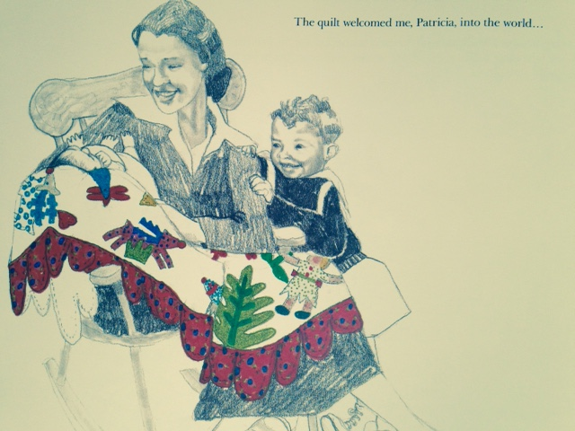**Question of the Week:** What lives on after a person dies?

**Gospel Character: receiving others honoring our ancestors**

**Family Activity:** 1) Offer support to someone who has a family member with a terminal illness. Anyone facing these realities walks closely realizing that death comes to us all. Sometimes even when one has so much life left in them. A person and a family that stands here is deeply in touch with all that has real value. Can you visit, send a card to or make a meal for a family in this place. Learn from them what Jesus is talking about in regards to our attachments to the things of this world. 2) Practice taking your eyes off your personal or family goals of attainment and put your eyes on the rest of the world and the realities that future generations will inherit. This is more difficult to do than you would think as modern advertising keeps feeding us that we need more and more and more telling us to think on. Work as a group to build the world that you want future generations to inherit. Activity: Have each group get a box to cut magazine pictures out to paste together a picture of the world they want future generations to inherit.

Bullet Points for Parents:

* This decade has taught us that anything is possible, the impact of 911, a major city flooded by a hurricane, a war we started and a global economic and environmental crisis.
* No matter what kind of materials we use to build our “castles” in this world, they all can come tumbling down. Whether we put our trust in financial structures, church leadership, the United States as a super power, family or job related status, all can come tumbling down. Jesus pulls us out of our attachments to be about someone and something bigger than ourselves.
* To truly follow Jesus we have to take on an eternal perspective. We have to be in touch with deeper selfless values, ones that will be still standing in the storm, in the grief, or in the burning down of our house and belongings.
* Jesus wants followers whose lives represent eternal values, the values of the kingdom of God. He promises that through giving up, we will be given more, inner treasures, one’s that “no thief can break in and steal”.
* Grandma Anna gave up all her riches to seek a more abundant life in a new country for her family and for the generations to follow. She did not live for today, hording her treasures, she lived for the future of her family, her children and her children’s children. Her life becomes a beautiful example of the invitation Jesus offers the rich young man, accepted.
* For every decision Native American’s make as a tribe they think about how this decision will affect the next seven generations. It is with this kind of heart that Jesus invites us to live lives beyond ourselves and lives rooted in the eternal perspective. Through this “key” the Camel’s Needle, which we can only get through on our knees (in humility) and with no belongings, we then will be able to pass through to live the life of abundance here and now. This is the heart that is rooted in eternal values. Only with God’s grace Jesus acknowledges is this possible.

Biblical Background Mark 10:17-30 Cycle B The 28th Sunday in Ordinary Time

**Geographical Setting:** In the beginning of chapter 10 Jesus leaves the Galilee region traveling south through the Jordan River Valley towards Judea. Judea is the region or county in which the city of Jerusalem sits. The journey from the Jordan to Judea would be from a river valley to hill country and mountains.

**Terms:**

**Rich man, eye of a needle** - Jesus and the kingdom of God is all about status reversal.  It is with humility, choosing to bow to another and their needs that one is raised.  In choosing status in the kingdom of God one will be lowered.  Like a camel would have to do to fit through an eye of a needle. Some scholars reflect that there was a passage or eye in a mountain area that camels would have to get down on their knees to get through. That is the image, it takes great humility and you can’t take anything with you to make it through, belongings would not fit. Sacrificial love is the way of the kingdom of God.  In opposition to the seeking of status the ways of the world encourage.

**“loved him” -** in Mediterranean culture love is translated as attachment in an active and practical way.  Jesus is attached to the young man, he wants him to be a true follower.  But Jesus can see there are many obstacles for the man to become truly free, thus the image of a camel through an eye of a needle.  Jesus in sadness recognizes there is too much for this man to let go of, he is not there yet.  So different than a poor man with little resources and attachment. The poor are in a freer state this state to respond to the call of Jesus, not so much to let go of.  Therefore ...blessed are the poor.

**Cultural Insights:** In Mediterranean times one’s possessions were family, home and land.  This is what gave one status or made one rich.  It is status that Jesus is saying all must forsake to be in the kingdom of God.  One must let go of these resources to seek the treasure of heaven.  God will replace the sources of sustenance for the person who willingly sacrifices.  Come follow me promises the rich man fellowship in a new community that is far larger and with more resources that one’s own family with limited resources can provide.

**Insight into Meaning:**In Mediterranean culture the greedy rich want for nothing because they surround themselves with resources that meet all their needs.  They are in control and act as God in their lives.  Therefore it is impossible to be a participant in the kingdom of God.  To receive the treasure of heaven one must be in a state of receptivity.  Therefore grace and goods can flow through one to meet the needs of the impoverished, those that stand wanting.  And one through emptying themselves for others can then be in a state to be given too, to be able to receive from God and others.  In this state of giving and receiving one’s family grows into all who share in this connection of giving and receiving. This is the state of being in the kingdom of God.  One who clings to their own resources is not in a state in which they can participate.  They are closed off.   One must be open and receptive to be nourished by the treasures of heaven.