Cycle A Mar.22, 2020

The 4th Sunday of Lent

Title: Born for Works of God

Theme: When one is born to lead one must be willing to SEE new visions and to dream new dreams!

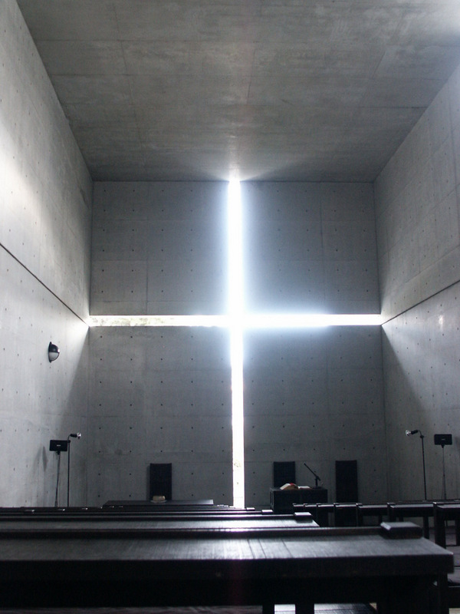 **Title: Interior of the Church of Light**

**Date: 1999 Artist: Tadao Ando Meduim: Architecture Building: Church of Light Place: Ibaraki, Japan**

Notes on Art: Mr. Ando has shown an ability to suffuse rooms with light in surprising ways. One of his most famous projects is the Ibaraki Kasugaoka Church in Ibaraki, Japan, which is known as the Church of the Light because of the cruciform-shaped opening in the concrete wall behind the altar." [from The New York Times, March 30, 2014.] -- "Dwelling in a house is a search for the mind (kokoro) as the locus of God, just as one goes to church to search for God. An important role of the church is to enhance this sense of the spiritual. In a spiritual place, people find peace in their mind (kokoro), as in their homeland." [ Jin Baek, Nothingness: Tadao Ando’s Christian Sacred Space. Routledge, 2009. ] -- Tadao Ando was the recipient of the Pritzker Prize in Architecture in 1995. -- Photo by Attila Bujdosó.

Story: The Legend of the Indian Paintbrush retold and illustrated by Tomie dePaola



Sunday Gospel

[Jn 9:1-41 or 9:1, 6-9, 13-17, 34-38](http://www.usccb.org/nab/bible/john/john9.htm#v1)

As Jesus passed by he saw a man blind from birth.  
His disciples asked him,  
“Rabbi, who sinned, this man or his parents,   
that he was born blind?”  
Jesus answered,  
“Neither he nor his parents sinned;   
it is so that the works of God might be made visible through him.  
We have to do the works of the one who sent me while it is day.  
Night is coming when no one can work.  
While I am in the world, I am the light of the world.”  
When he had said this, he spat on the ground  
and made clay with the saliva,  
and smeared the clay on his eyes,  
and said to him,   
“Go wash in the Pool of Siloam” —which means Sent—.  
So he went and washed, and came back able to see.

His neighbors and those who had seen him earlier as a beggar said,   
“Isn’t this the one who used to sit and beg?”  
Some said, “It is, “  
but others said, “No, he just looks like him.”  
He said, “I am.”  
So they said to him, “How were your eyes opened?”  
He replied,  
“The man called Jesus made clay and anointed my eyes  
and told me, ‘Go to Siloam and wash.’  
So I went there and washed and was able to see.”  
And they said to him, “Where is he?”  
He said, “I don’t know.”

They brought the one who was once blind to the Pharisees.  
Now Jesus had made clay and opened his eyes on a sabbath.  
So then the Pharisees also asked him how he was able to see.  
He said to them,  
“He put clay on my eyes, and I washed, and now I can see.”  
So some of the Pharisees said,  
“This man is not from God,  
because he does not keep the sabbath.”  
But others said,  
“How can a sinful man do such signs?”  
And there was a division among them.  
So they said to the blind man again,   
“What do you have to say about him,  
since he opened your eyes?”  
He said, “He is a prophet.”

Now the Jews did not believe   
that he had been blind and gained his sight   
until they summoned the parents of the one who had gained his sight.  
They asked them,  
“Is this your son, who you say was born blind?  
How does he now see?”  
His parents answered and said,   
“We know that this is our son and that he was born blind.  
We do not know how he sees now,  
nor do we know who opened his eyes.  
Ask him, he is of age;  
he can speak for himself.”  
His parents said this because they were afraid  
of the Jews, for the Jews had already agreed   
that if anyone acknowledged him as the Christ,  
he would be expelled from the synagogue.  
For this reason his parents said,  
“He is of age; question him.”

So a second time they called the man who had been blind   
and said to him, “Give God the praise!  
We know that this man is a sinner.”  
He replied,  
“If he is a sinner, I do not know.  
One thing I do know is that I was blind and now I see.”  
So they said to him,  
“What did he do to you?  
How did he open your eyes?”  
He answered them,  
“I told you already and you did not listen.  
Why do you want to hear it again?  
Do you want to become his disciples, too?”  
They ridiculed him and said,   
“You are that man’s disciple;  
we are disciples of Moses!  
We know that God spoke to Moses,   
but we do not know where this one is from.”  
The man answered and said to them,  
“This is what is so amazing,   
that you do not know where he is from, yet he opened my eyes.  
We know that God does not listen to sinners,   
but if one is devout and does his will, he listens to him.  
It is unheard of that anyone ever opened the eyes of a person born blind.  
If this man were not from God,  
he would not be able to do anything.”  
They answered and said to him,  
“You were born totally in sin,  
and are you trying to teach us?”  
Then they threw him out.

When Jesus heard that they had thrown him out,  
he found him and said, "Do you believe in the Son of Man?"  
He answered and said,   
“Who is he, sir, that I may believe in him?”  
Jesus said to him,  
“You have seen him,  
the one speaking with you is he.”  
He said,  
“I do believe, Lord,” and he worshiped him.  
Then Jesus said,  
“I came into this world for judgment,   
so that those who do not see might see,   
and those who do see might become blind.”

Some of the Pharisees who were with him heard this   
and said to him, “Surely we are not also blind, are we?”  
Jesus said to them,  
“If you were blind, you would have no sin;   
but now you are saying, ‘We see,’ so your sin remains.

**Making the Connections for Parents and Catechists:**

What is it that Little Gopher and The Man Born Blind have in common? Both seem to have a common destiny, a unique and specific role that they were ‘born to play’ on God’s behalf for their communities. The man born blind grows up as a person set apart. As too does Little Gopher. He doesn’t fit in with the activities that most young men participate in, I am sure that the blind man felt the same way most of the time. A wise shaman plays an important role in the life of Little Gopher. A role of encouragement, “Your place among the people will be remembered for a different reason” he said to Little Gopher. Jesus played a huge role in helping the blind man to see his role. The question wasn’t one of was his blindness a result of his or his parents sin? The question was, “What role would he fulfill?” Jesus said, “Neither he nor his parents sinned; it is so that the works of God might be made visible through him.”

“What does this gospel story mean for us?” This is always the questions of the message and miracles of Jesus. Both young men are sent on a Vision Quest, to see what others can’t see and bring it back to the community. This is the traditional role of the prophet, both men are acting as prophets here. The Shaman sends Little Gopher on his vision quest. He goes willing and receptively to listen to the voice of God. Jesus sends the Blind Man to a public pool in the middle of everything with mud on his eyes. Imagine standing in the middle of the public plaza, and a blind man with his eyes covered in mud makes his way to the public fountain. What a teachable moment Jesus makes of this. Jesus has been sent to fulfill the work of the Pharisees, the religious leaders. But they can’t see it, their eyes are covered with mud. Only with humility and reliance upon God, the ways of the blind man, can one see the presence and actions of the God.

Jesus came to liberate all, and through this gospel story he illustrates the paths to become unbound. Both the blind man and Little Gopher were given sight through their leaps and journeys of faith. They were given inner sight. What a gift this is. Both were chosen to demonstrate God’s works through. With the blind man works that would teach others of Jesus’ way, truth and life.

God uses the young and the broken, as he did in these stories to confound the ‘wisdom of the day”. The blind man was not as set in his ways as his parents, he was not as fearful. He was open to a new paradigm for religious truth and freedom. His parents were not. Little Gopher like the blind man, followed his call from within. After his vision quest, like the blind man, he had seen God. Therefore, he could see God in all things. Now he could be lead from within, and he could lead his people to a place they had not yet seen. Brand new horizons, understandings and colors. The blind man could do the same, he went from being blind, to speaking before the important lawmakers of his land, speaking before crowds, to challenging the religious leaders of the day. “Why do you ask so many questions he inquires, are you seeking to become like me, the once blind man?” he asks the Pharisees.

The young can lead the old, as a matter of fact, it’s the job of the young to dream of a new world, to imagine the unimaginable. To bring about “all things new” the young must be able to see within. It’s within the chambers of the heart that God begins to create a new song. It’s the way of our tradition if we open our eyes to see, a baby, the Messiah, born in a stable. Obstacles, to those who were watching and waiting. Miracles to those who were open and listening, and could see!!

Bullet Points for Parents:

* Little Gopher and The Man Born Blind both seem to have a common destiny, a unique and specific role that they were ‘born to play’ on God’s behalf for their communities.
* The man born blind grows up as a person set apart, so does Little Gopher. He doesn’t fit in with the activities that most young men participate in, I am sure that the blind man felt the same way most of the time.
* The wise shaman played an important role in the life of Little Gopher. A role of encouragement, “Your place among the people will be remembered for a different reason” he said to Little Gopher.
* Jesus played a huge role in helping the blind man to see his role. The question wasn’t one of was his blindness a result of his or his parents sin? The question was, “What role would he fulfill?” Jesus said, “Neither he nor his parents sinned; it is so that the works of God might be made visible through him.”
* “What does this mean for us?” is always the questions of the message and miracles of Jesus. Both young men in our stories today have their Vision Quest. The Shaman sends Little Gopher on a mission. He goes willing and receptively to listen to the voice of God. Jesus sends the Blind Man to a public pool in the middle of everything with mud on his eyes. Imagine standing in the middle of the public plaza and a blind man with his eyes covered in mud makes his way to the pools.
* What a teachable moment Jesus makes of this. Jesus has been sent to fulfill the work of the Pharisees and the religious leaders. But they can’t see it, their eyes are covered with mud. Only with humility and reliance upon God, which were the ways of the blind man Jesus points out, could one come to fully see the presence of the God within. It is God’s desire Jesus teaches, to free all from the challenges we find ourselves in, of all that binds us.
* Jesus came to liberate us and through this story he illustrates for us today the paths that we must be on to discover the same liberation the blind man. Both the blind man and Little Gopher were given sight through their leaps and journeys of faith. They were given inner sight. What a gift this is. Both were chosen by God for God to demonstrate the works Of God through. Works that would teach others of Jesus and his way, his truth and his life.

**Making the Connections for Children:**

1. How were the works of God visible in Little Gopher?
2. How were the works of God made visible in the man born blind?
3. Sometimes do we put people in a box and don’t see what they must contribute? How is that limiting?
4. Jesus shows in healing the blind man that God’s gifts coming alive in a person makes their life limitless. What healing does both the blind man and Little Gopher experience?
5. What does it do for them?
6. What does it do for their communities?
7. Sometimes do you feel like you have a gift and purpose in you that no one can see?
8. How can you learn to trust it and believe in what is in you?
9. What did Little Gopher see that no one else could?
10. What could the Blind Man see that the religious leaders couldn’t?
11. What do you think it means to see with your heart? Do you think Little Gopher could do that?
12. What could the blind man see that no one else could?
13. What are some things you see that you feel no one else can? How can you sharing your insights make a lasting difference?

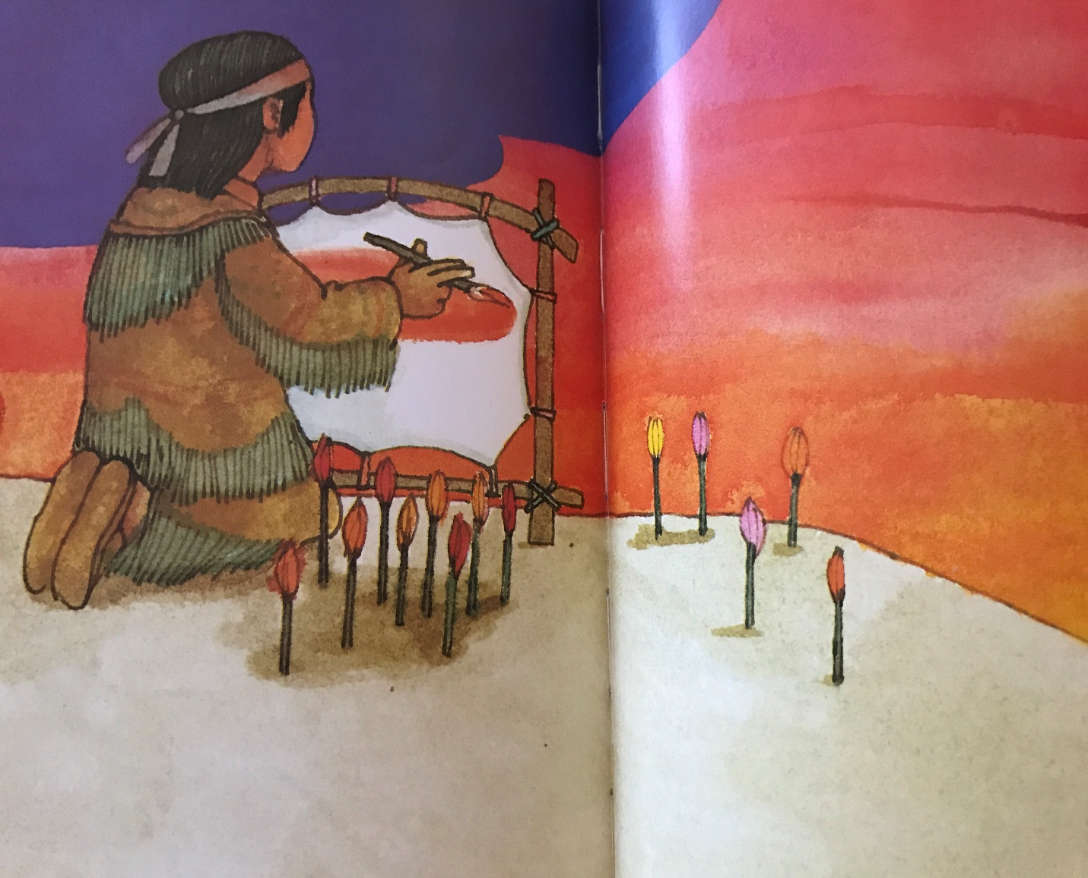

**Question of the Week:** How as a family might you be called to help the blind see? What ways do you think as a family you might experience blindness?

**Gospel Character Qualities:** **Seeing through Imagination, Daring to be different See who you are**

**Additional Family Activity:** 1) Have a family paint-out. Go out to a park or your back yard and study nature. Bring paints and paper, take time to really see. What do you see that you might have missed when you study something God created to recreate it? Practice listening, what do you hear, what do you see? Share with each other what you learned from the experience. 2) Take time as a family to visit with a person who is blind. Learn from them all the things they “see” that others might miss.

#### Biblical Background Cycle A The 4th Sunday of Lent John 9:1-38

**Geographical Setting:** The man born blind was placed at the entrance to the Temple Mount each day by his family.  He is a person to whom you would give alms.  He was alms worthy because of his blindness.  He would have been a familiar figure on the southern steps leading into the Temple Mount because thousands of pilgrims would pass through this entrance daily.  They were coming to the Temple to pray and to make offerings.  It was a blessing to have persons like the blind man to give alms to along the way.  God is pleased with this sort of exchange.

**Terms**

**Sabbath -** Jesus healed this man on the Sabbath even though his condition was not life threatening.  You could save a life on the Sabbath but anything more than that was considered work.  This man was blind and had been blind since his birth.  He could be healed on any other day.  Why did Jesus have to desecrate the Sabbath by healing him in the holy day?

The Sabbath lasted from sundown on Friday until sundown on Saturday evening.  This healing took place on Saturday morning when thousands of worshipers were on their way to the Temple.

**Temple visits:** A visit to the temple would begin with being ritually bathed in the Pool of Siloam before entering the Temple area.  Many would have seen this man, with a paste of mud over his eyes, rushing past them to wash in the public pool in the southern City of David.

**The Prophet -** Since the time of Moses, for over 1500 years, the Jewish faith community has been waiting for a new Moses to arrive on the scene.  Moses promised (Dt. 18:15) that one day another Prophet like himself would arise to lead Israel.  The Jews have been waiting for this new Moses.  Our formally blind man wonders if Jesus might be the Prophet, the new Moses, who would lead Israel.  Moses was a Prophet who was powerful in word and deed.  He spoke and he performed miracles among the people.  Jesus is doing the same and the healed man reminds the religious leaders that to his knowledge no one had ever restored the sight of a man born blind.  Therefore, the religious leaders challenge the parents of the man to prove that he was born blind.  This miracle amazes them all.

**Cultural Insight -** In the longer version of this Gospel story the account begins with a question that the disciples ask Jesus.  "Who sinned? This man or his parents that he was born blind?"  They know this man.  He has been in this place soliciting alms for as long as they can remember.  They wonder what the cause and effect of the sin equation is in this situation.  Jesus responds by saying that neither he nor his parents sinned.  That is not why he is blind and has been since his birth.  Rather, sometimes people are just born blind.  Jesus then uses this occasion to display the authority he has as a healer and restores sight to this man.

**Insight into Meaning:** The man does not ask to be healed.  If asked he might have said no.  He is an alms worthy recipient in his current condition.  If his sight is restored how will he support himself and his family?  Every Jew is obliged to pray, too fast and to give alms.  God is obliged to provide alms worthy persons for our generosity.  This man performs a valuable religious service in the faith community.  Jesus changes the course of his life and then finds him later to console him with the news that he has met and has been healed by the very Messiah of God.  It has been a good day for him, his family and the whole community. Yet it is towards the religious leaders who remain the ones blind that Jesus hopes to fully impact.